

Software Requirements Specification (SRS) is one of the first phases of system development. This phase results in the Software Requirements Specification (SRS) document, which must contain a complete, concise, high-quality description of the system being considered.

Software Requirement Document- Admission
Sustainable Outreach And Universal
Leadership (SOUL) Limited

Table of Content

1. Abstract (Change) 4
2. Introduction 4
Purpose 4
Scope 4
3. Definition, Acronyms and Abbreviations 4
4. Overview of the Document 5
5. Detailed requirement 5
6. WSC Student Admission Flowchart 6
7. Flowchart Description 6
7.1 Masters 6
7.2 Admission Masters 6
7.3 Student Admission 7
7.4 Student Applicant 7
7.5 Entrance Exam Declaration 7
7.6 Admit Card 7
7.7 Entrance Exam Evaluation 7
7.8 Rank Card Publication 7
7.9 Counselling 7
7.10 Student 7
7.11 Course Enrollment 7
8. Overall Screens and Their Descriptions : 7
Sl no 7
Existing Application Screen Name 7
Description 7
1. Admission: 10
1.1 Admission Home Screen 10
1.2 Department 10
1.3 Program Grade 12
1.4 Programs 13
1.5 Semester 15
1.6 Course 17
1.7 Academic Year 20
1.8 Academic Term 21
Field List 22
1.9 Class Room 22
1.10 Student Admission 23
1.11 Student Applicant 29
1.12 Program Enrollment 36
1.13 Course Enrollment 40
1.14 Fee Category 43
1.15 Fee Structure 44
1.16 Fee Schedule 45
1.17 Fees 47
1.18 Student 50
1.19 Instructor 56
1.20 Student Re registration Tool 59
1.21 Entrance Exam Declaration 60
1.22 Admit Card Issue 61
1.23 Document Template 63
1.24 Academic Event 64
1.25 Awards 65
1.26 Country 66
1.27 State 67
1.28 Districts 68
1.29 Block 69
1.30 Documents 69
1.31 Eligibility Parameter 70
1.32 Student Batch Name 71
1.33 Religion 72
1.34 Fee Type 73
1.35 Entrance Exam Evaluation 74

Abstract (Change)

Software Requirements Specification (SRS) is one of the first phases of system development. This phase results in the Software Requirements Specification (SRS) document, which must contain a complete, concise, high-quality description of the system being considered.

Introduction

Purpose
This document covers all the functional requirements of the Education module of ERP Product. The ERP Education module helps in organizing the entire education set-up, such as Student Database, Fee Structure, Staffing Information, Courses, Curriculum, Assessment and Result Declaration

Scope
This module handles the entire Admission Process of Students. It helps the organization to manage the new student application forms, approval of student applications, student admission, managing student admission fee structures

Definition, Acronyms and Abbreviations

The following table explains the terms and abbreviations used in the document

Abbreviation | Description
SRS | Software Requirements Specification
SLCM | Student Life Cycle Management
R | Rename - When a field is Renamed
N | New - When a New field is Added
D | Delete - When an Existing field is Deleted

Overview of the Document

Student success is always considered as the top priority for any institution, students always are considered as the base of any educational institution. So various works are associated with students right from their admission process to the completion of their education.
Previously, all the tasks related to student success were dependent on a lot of manual work that included organizing marketing activities for universities to attract fresh prospects, track their interests, nurture them through continuous engagement, these are just some of the things that come under student life cycle management.

It enable you to manage and create quick & easy-to-use student profile information, the inquiry process, enrollment for admission, link to enroll, schedule, transcript, and degree evaluation, and share records with faculties, and administrators.
It also can track student performance from his first-class to his last class in the university that is course completion, managing information across the entire student life cycle to advance students.

Detailed requirement

Requirements documentation describes the business solution for a particular project, including the user's expectations and needs, the purpose behind that solution, and any high-level constraints that can affect successful deployment. The requirement provided by WSC team such as: Students Management Modules Students Profile :Personal Information, Contact Details, Academic Details, Issue of Identity Card. Rewards and achievements.

WSC Student Admission Flowchart
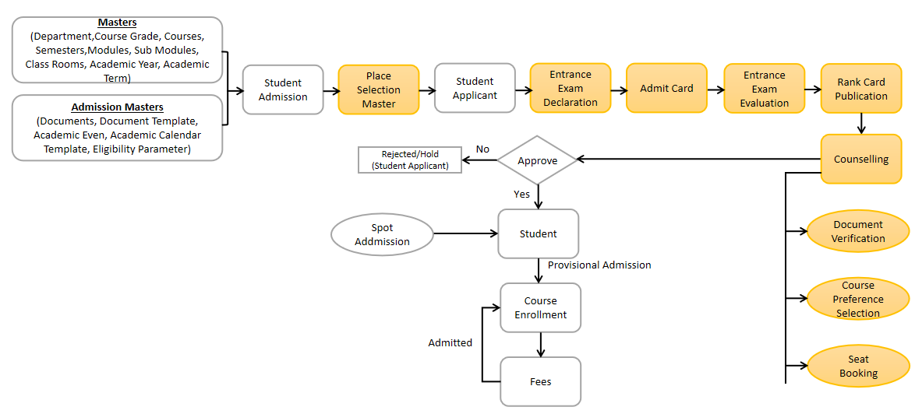

Flowchart Description

Masters
The education Master module needs the following master data.
- Department
- Course
- Semester
- Module
- Topic
- Academic Year
- Academic Term
- Class Room
- State
- Districts
- Blocks
- Gender
- Religion

Admission Masters
Admission Master Process needs the following Master data :
- Document Name
- Academic Event
- Documents Templates
- Academic Calendar Template
- Eligibility Parameters
- Student Batch
- Award Winner
- Physically Disabled
- Fee Type

Student Admission
Student Admission Process will be used to configure the Admission for different courses, regarding their eligibility criteria, documents requirement, Counselling Structure, etc.

Student Applicant
Student Applicant Card contains the application form by which students can apply for their respective courses for getting admission.

Entrance Exam Declaration
Entrance Exam Declaration process having the details for declaring entrance exams for the student applicants.

Admit Card
Admit card contains the details of individuals student applicants records such as their exam data, time, venue, course details, etc.

Entrance Exam Evaluation
Entrance Exam Evaluation process includes the result publish process of every student applicants who had applied for Entrance Examination.

7.8 Rank Card Publication
Rank Card Publication card represents the process of giving ranks to the eligible student applicants for admission.

7.9 Counselling
Counselling Process includes the document verification, course preference selection, slot booking, fee payment for the different rank holder student applicants for various courses.

7.10 Student
After approval of Student applicants, Student screen is created where all the general details of individual students are present.

7.11 Course Enrollment
Course enrollment card represents the enrollment of students in to different courses as a provisional admission but after fee payment, the students are actually admitted into their respective courses.

Overall Screens and Their Descriptions :
The following tables lists the pages used in Admission module :

Sl no | Existing Application Screen Name | Description
 | Department | A Department is a specialized functional area or a division within an organization.
 | Course Grade | A Program Grade is a specialized functional area or a division within the Department.
 | Course | A program will have an educational curriculum defined by user institute to streamline the learning process and goals in each subject or module.
 | Semester | A semester is individual part of a program. A semester system divides the academic year into different sessions which have various course enrollments enlisted in them.
 | Module | A module can be considered as a subject or a part of an educational program which is to be taught for a term
 | Topic | A Topic is a sub unit of a Module and will contain all the contents related to the topic.
 | Class Room | Class room refers to a tutoring space which can be set as the venue for courses or examinations.
 | Academic Year | An academic year is a period which the Educational Institutes, Schools and Universities use to measure a quantity of study.
 | Academic Term | An Academic Term would become a part of the Academic Year, during which the Institute will assess its students on the curriculum defined for that term.
 | Document Template | Document template contains the documents name needed with respect to different courses for different academic years.
 | Academic Calendar | Academic Calendar contains the different events for a particular year for every individual courses.
 | Student Admission | Student Admission is a document which can be configured to initiate an admission Process for user by publishing it on the Institute website.
 | Student Applicant | A Student Applicant record gets created when a student applies to your institute for admission.
 | Program Enrollment | Program Enrollment is the record of enrollment of a student in a given program and chosen courses for a particular Academic Term.
 | Course Enrollment | Course Enrollment is the record of enrollment of a student in a given program and chosen courses for a particular Academic Term.
 | Student | The Student document will hold all the data related to the students.
 | Instructor | An instructor is a teacher, tutor, or a professor who will be responsible for teaching a particular topic or course to the students.
 | Student Re registration Tool | Student Re registration tool mainly help for enrolling the students into their next semester bulk wise only after the enrollment of first semester.
 | Student Category | Student Category is based upon the castes of the students such as ST, SC, General, Etc.
 | Student Batch | Student Batch defines every student groups on the basis of their batch.
 | Fee Category | Fee Category would form all the components for calculation of Fees or creation of Fee Structure.
 | Fee Structure | A Fee Structure is a template that can be used while making Fees records or generating them via the Fee Schedule.
 | Fee Schedule | Fee Schedule would help in defining a time-line for the Fee payment of the students, based on the Student Group.
 | Fees | Every individual students Fee Records are maintained in the Fees screen
 | Academic Event | Academic Event screen consists of different types of event list like Holidays, Examination and their dates.
 | Documents | Documents screen contains the different document names such as Aadhar Card, Certificates, etc.
 | Awards | Awards is Master Screen, you can create different types of awards such as State, National, International Awards, etc.
 | Country | Country is Master Screen, we can create different country such as India, Afghanistan, etc. This will be fetched when creating new addresses.
 | State | State is Master Screen, you can create different states such as Odisha, West Bengal, etc
 | Districts | District is Master Screen, you can create different district name such as Khordha, Kandhamal, etc in the state Odisha
 | Blocks | Block is Master Screen, you can create different blocks name such as Baranga, Niali, etc in the Cuttack district of Odisha
 | Eligibility Parameter | Eligibility Parameter is Master Screen, you can create different eligibility parameters name such as 10th, 12th, ITI, Poly technique, etc.
 | Religion | Religion is a Master Screen, where we can create different religion names such Muslim, Hinduism, Christianity, etc.
 | Fee Types | Fee Type is a Master Screen where we can create different fee types such as Semester Fees, Hostel Fees, Mess Fees, etc.
 | Entrance Exam Declaration | Entrance Exam Declaration screen shows the Department Name, Course Name, Entrance Date, Entrance Time, Description for the Entrance Examination.
 | Student Admit Card | Admit Card refers to the student Applicant where individual Admit card will be provided to the students applicants after entrance exam declaration having their respective exam details.
 | Entrance Exam Evaluation | Entrance Exam Evaluation screen contains the entrance result of student applicants

Admission:

1.1 Admission Home Screen

This is the Homepage for the logged in User:

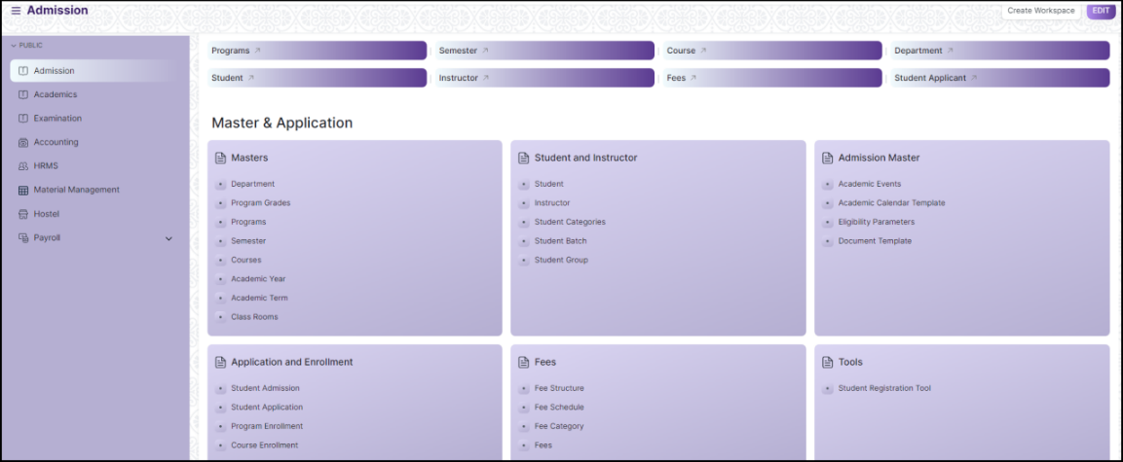
Figure 1 : Admission Homepage

1.2 Department

General Description

The following table describes overall information about this screen:
Description |  | - A Department is a specialized functional area or a division within an organization.  - User will configure the Departments, set Leave Block List and also Leave and Expense Approvers for the same.  - Department is a tree-structured master, which means user can create parent departments and sub-departments as shown below
Navigation | Home > Admission > Masters > Department
Pre-requisites | The system should have records in the following screen  - Company  - Leave Block List
Existing Screen Name | Department
New Screen Name | No change

Screenshot

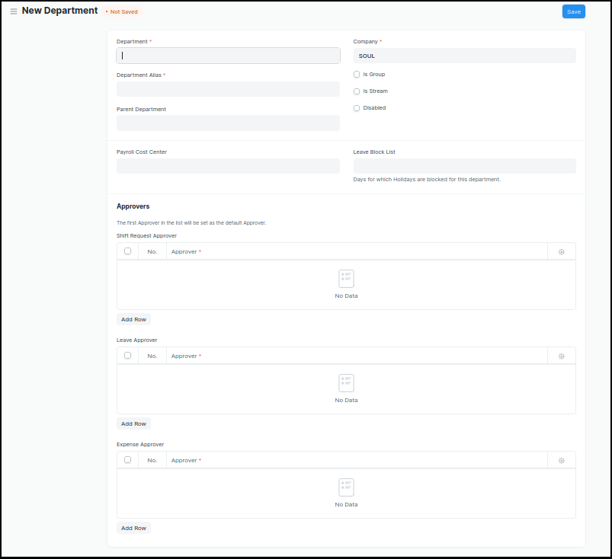
Figure 2 : Department Screen

Field List

The following table describes the UI fields present in this screen :

ID | Label | Type | Mandatory | Validation/ Action | Remarks | R = Rename  N= New  D= Delete
1 | Department | Text Field | Yes
2 | Parent Department | Link Field
3 | Company | Link Field | Yes | Link Fields to Master Screen Company | Default company name will be fetched
4 | Is Group | Checkbox |  | If checked the department will be grouped under a parent department
5 | Is Stream | Checkbox |  | If checked the department will be considered as a stream E.g (Commerce, Arts, Etc)
6 | Disabled | Checkbox |  | If checked, the department record will not be able to visible in any transaction
7 | Payroll Cost Center | Link Field |  |  | Not Applicable for Admission Module
8 | Leave Block List | Link Field |  |  | Not Applicable for Admission Module
10 | Leave Approver | Table |  |  | Not Applicable for Admission Module
11 | Expense Approver | Table |  |  | Not Applicable for Admission Module
12 | Shift Request Approver | Table |  |  | Not Applicable for Admission Module

User: Roles & Permission

The following table describes the users and their roles and permissions for the screens :
ID | Role | Read | Write | Create | Delete | Submit
1 | Admin | Yes | Yes | Yes | Yes | NA
2 | Instructor | Yes | No | No | No | NA
3 | Student | Yes | No | No | No | NA
4 | Student Applicant | Yes | No | No | No | NA

1.3 Program Grade

General Description

The following table describes overall information about this screen:

Description | - A Program Grade is a specialized functional area or a division within the Department.  - User can add or modify Program Grade and Link Field Programs to it.
Navigation | Home > Admission > Masters > Program Grade
Pre-requisites
Existing Screen Name | Program Grade
New Screen Name | Course Grade

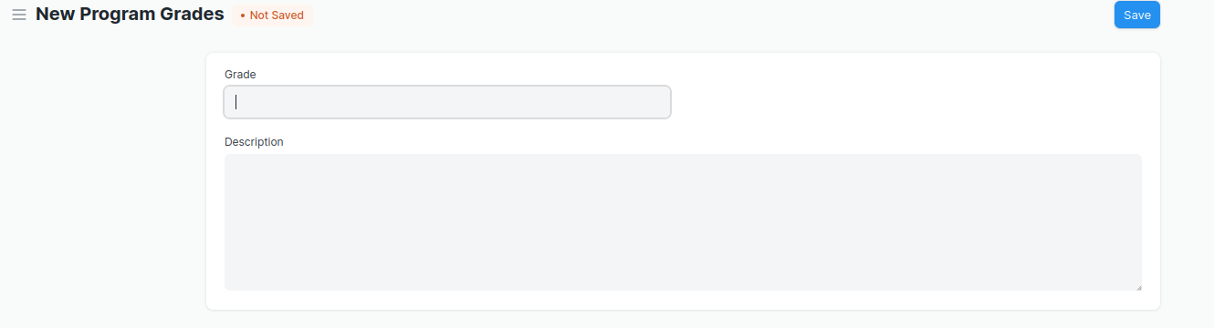
Screenshot

Figure 3 : Program Grade Screen

Field List

The following table describes the UI fields present in this screen :

ID | Label | Type | Mandatory | Validation / Action | Remarks | R = Rename  N= New  D= Delete
1 | Grade | Text Field | Yes
2 | Description | Long Text

User: Roles & Permission

The following table describes the users and their roles and permissions for the screens :

ID | Role | Select | Read | Write | Create | Delete | Submit
1 | Admin | Yes | Yes | Yes | Yes | Yes | NA

1.4 Programs

Description | - A program will have an educational curriculum defined by user institute to streamline the learning process and goals in each subject or module.  - For example, Mechatronics would be a program taught at the institute that will have various modules within
Navigation | Home > Admission >Masters > Course
Pre-requisites
Existing Screen Name | Programs
New Screen Name | Course
General Description

The following table describes overall information about this screen:

Screenshot

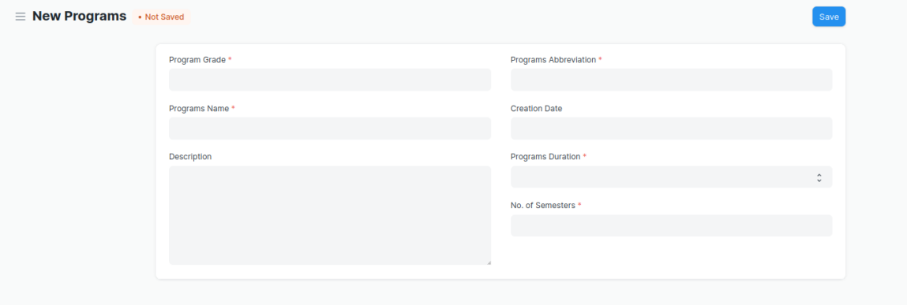
Figure 4 : Programs Screen

Field List

The following table describes the UI fields present in this screen :

ID | Label | Type | Mandatory | Validation / Action | Remarks | R = Rename  N= New  D= Delete
1 | Program Grade | Link Field | Yes | Links with Program Grade Screen |  | (R) Course Grade
2 | Programs Name | Data | Yes |  |  | (R) Course Name
3 | Department | Link Field | Yes | Links with Department Screen
4 | Description | Small Text
5 | Programs Abbreviation | Text | Yes |  |  | - Course  Abbreviation
6 | Creation Date | Date
7 | Programs Duration | Dropdown | Yes | 1 Year  2 Years  3 Years  4 Years  5 Years  6 Years  7 Years  8 Years  9 Years  10 Years |  | (R) Course Duration
8 | No. of Semesters | Number | Yes
9 | Add Semesters | Button |  | After saving the record, this button  Will be visible to the user.
Semesters Table
11 | Semesters | Link Field |  | Semester will automatically created after clicking on the button Add Semesters w.r.t. the Program Abbreviation Name
12 | Semesters | Text |  | Semesters name auto fetch from semesters screen

User: Roles & Permission

The following table describes the users and their roles and permissions for the screens :

ID | Role | Select | Read | Write | Create | Delete | Submit
1 | Admin | Yes | Yes | Yes | Yes | Yes | NA
2 | Instructor | Yes | Yes
3 | Student | No | Yes | No | No | No

1.5 Semester

General Description

The following table describes overall information about this screen:
Description | - A semester is individual part of a program. A semester system divides the academic year into different sessions which have various course enrollments enlisted in them.  - For example, a program in Mechatronics can consist of 2 semesters.
Navigation | Home > Admission > Masters > Semester
Pre-requisites | - Department  - Course Grade  - Course
Existing Screen Name | Semester
New Screen Name | No change
Screenshot

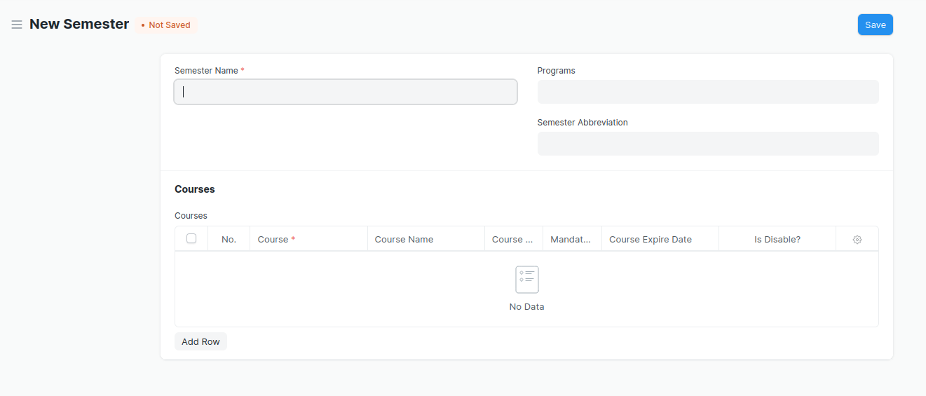
Figure 5 : Semester Screen

Field List

The following table describes the UI fields present in this screen :

ID | Label | Type | Mandatory | Validation / Action | Remarks | R = Rename  N= New  D= Delete
1 | Semester Name | Text | Yes
2 | Department | Link Field
3 | Programs | Link Field | Yes | Program Name will come in a drop down on the basis of Department Name. |  | ( R )Course
4 | Semester Abbreviation | Text
Courses Table | Programs Abbreviation | Text | Yes |  |  | - Course  Abbreviation
5 | Course | Link Field | Yes | Links with Course Screen |  | ( R ) Module
6 | Course Name | Text |  | Auto fetched when course is entered |  | ( R ) Module
7 | Course Code | Text |  | Auto fetched when course is entered |  | ( R ) (Module)
8 | Mandatory | Checkbox
9 | Modes | Dropdown |  | Auto fetched when course is entered
10 | Course Expire Date | Date |  | Auto fetched when course is entered |  | ( R ) Module
11 | Is Disable? | Checkbox |  | Auto fetched when course is entered

User: Roles & Permission

The following table describes the users and their roles and permissions for the screens :

ID | Role | Select | Read | Write | Create | Delete | Submit
1 | Academics user | No | Yes | Yes | Yes | Yes | No
2 | Instructor | No | Yes | Yes | Yes | Yes | No
3 | Student | No | Yes | No | No | No | No

1.6 Course

General Description

The following table describes overall information about this screen:

Description | - A module can be considered as a subject or a part of an educational program which is to be taught for a term  - For example, if for a particular term, Mechatronics is a Course taught in the institute, then Pneumatics would be a Module covered under the Course.  - A module will have a set of sub module that are to be covered under its scope.
Navigation | Home > Admission > Masters > Module
Pre-requisites | - Department  - Course Grade  - Course  - Semeste  - Assessment Criteria
Existing Screen Name | Course
New Screen Name | Module

Screenshot

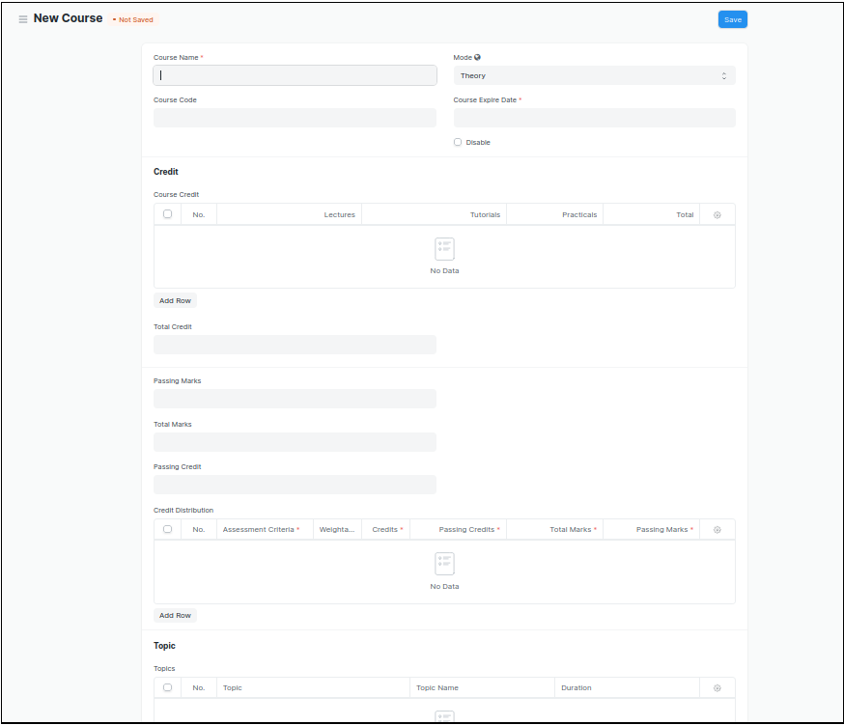
Figure 6 : Course Screen

Field List

The following table describes the UI fields present in this screen :

ID | Label | Type | Mandatory | Validation / Action | Remarks | R = Rename  N= New  D= Delete
1 | Course Name | Text | Yes |  |  | ( R ) Module Name
2 | Course Code | Text | Yes |  |  | ( R ) Module Code
3 | Mode | Dropdown |  | Theory  Practical  Both
4 | Course Expire Date | Date | Yes |  |  | ( R ) Module Expire Date
5 | Disable | Checkbox |  | If Checked, then course should not be visible in any transaction.
Course Credit |  |  | Yes | Links with Course Screen |  | ( R ) Module
6 | Lectures | Float |  |  |  | ( D )
7 | Tutorials | Float |  |  |  | ( D )
8 | Pacticals | Float |  |  |  | ( D )
9 | Total | Float |  | Total Will be auto calculate  The sumof L, T & P |  | ( D )
10 | Total Credit | Float |  | Total Credit Will be auto calculate  the sum of L, T & P |  | ( D )
11 | Passing Marks | Float
12 | Total Marks | Float
13 | Passing Credit | Float |  |  |  | ( D )
Credit Distribution
14 | Assessment Criteria | Link Field | Yes
15 | Weightage | Percentage | Yes
16 | Credits | Float | Yes |  |  | ( D )
17 | Passing Credits | Float | Yes |  |  | ( D )
18 | Total Marks | Float | Yes | Weightage will be auto fetched in Total Marks
19 | Passing Marks | Float | Yes
Topic
20 | Topic | Link Field |  | Links with Topic Screen
21 | Topic Name | Text |  | Auto fetch the Topic Name when topic is entered
22 | Duration | Duration
23 | Attach lesson plan | Attach |  | - On attachment a dialogue box will be popup where user can attach the files, take the picture with the help camera and can link any URL.  - If photos or images attached then the size will be maximum 200 kb.
24 | Action/ Add to Semester | Action Button |  | A popup will open, you need to choose the semester name, where you want to Link .
User: Roles & Permission

The following table describes the users and their roles and permissions for the screens :
ID | Role | Select | Read | Write | Create | Delete | Submit
1 | Admin | No | Yes | Yes | Yes | Yes | No
2 | Instructor | No | Yes | Yes | Yes | Yes | No
3 | Student | No | Yes | No | No | No | No

1.7 Academic Year
General Description

The following table describes overall information about this screen:
Description | - An academic year is a period which the Educational Institutes, Schools and Universities use to measure a quantity of study.  - The Academic year form have the Start and End date for the Academic year. Within an Academic Year, user can have multiple Academic Terms.
Navigation | Home > Admission > Masters > Academic Year
Pre-requisites
Existing Screen Name | Academic Year
New Screen Name | No change

Screenshot

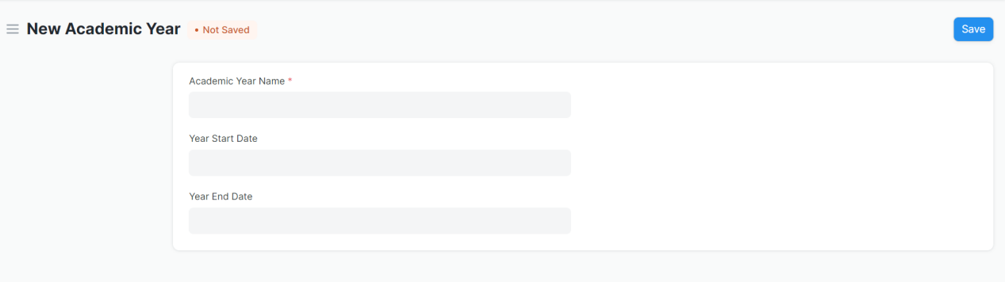
Figure 7 : Academic Year Screen

Field List

The following table describes the UI fields present in this screen :

ID | Label | Type | Mandatory | Remarks | R= Rename  N= New  D= Delete
1 | Academic Year Name | Text | Yes
2 | Year Start Date | Date | Year Start date should be before the Term End Date
3 | Year End Date | Date | Year End date should be greater then Term Start Date

User: Roles & Permission

The following table describes the users and their roles and permissions for the screens :

ID | Role | Select | Read | Write | Create | Delete | Submit
1 | Admin | Yes | Yes | Yes | Yes | Yes | Yes
2 | Academics user
3 | Instructor | Yes | Yes | No | No | No | No

1.8 Academic Term

General Description

The following table describe overall information about this screen:
Description | - An Academic Term would become a part of the Academic Year, during which the Institute will assess its students on the curriculum defined for that term. It could be a Quarter, Trimester or a Semester.  - The Academic term form enables user to create academic terms within an Academic Year.
Navigation | Home > Admission > Masters > Academic Term
Pre-requisites | Academic Year
Existing Screen Name | Academic Term
New Screen Name | No change

Screenshot

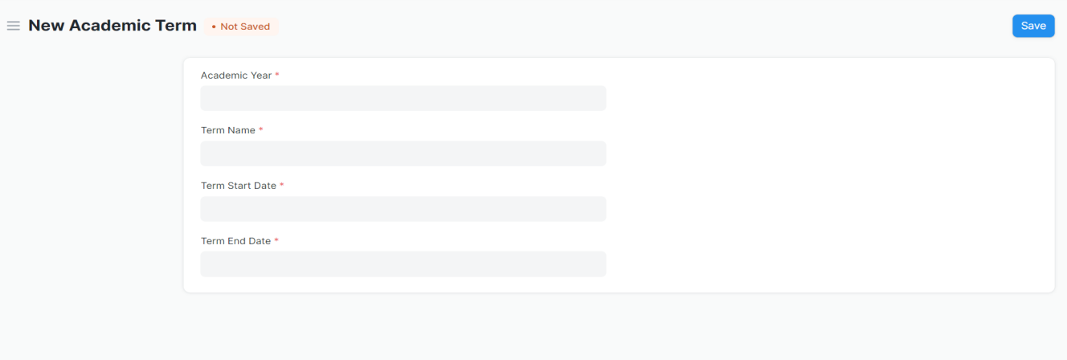
Figure 8 : Academic Year Screen

Field List

The following table describes the UI fields present in this screen :
ID | Label | Type | Mandatory | Action / Validation | R= Rename  N= New  D= Delete
1 | Academic Year | Link Field | Yes | Links with Academic Year Screen
2 | Term Name | Text | Yes
3 | Term Start Date | Date | Yes | Term Start date should be before the Term End Date
4 | Term End Date | Date | Yes | Term End date should be greater then Term Start Date

User: Roles & Permission

ID | Role | Select | Read | Write | Create | Delete | Submit
1 | Admin | Yes | Yes | Yes | Yes | Yes | Yes
2 | Academics user
3 | Instructor | Yes | Yes | No | No | No | No
The following table describes the users and their roles and permissions for the screens :

1.9 Class Room

General Description

The following table describes overall information about this screen:
Description | - Class room refers to a tutoring space which can be set as the venue for courses or examinations.  - Examples of a room are Examination Halls, Classrooms, or Labs. The Room will have details like Room number and Room Capacity.
Navigation | Home > Admission > Masters > Room
Pre-requisites
Existing Screen Name | Class Room
New Screen Name | No change

Screenshot

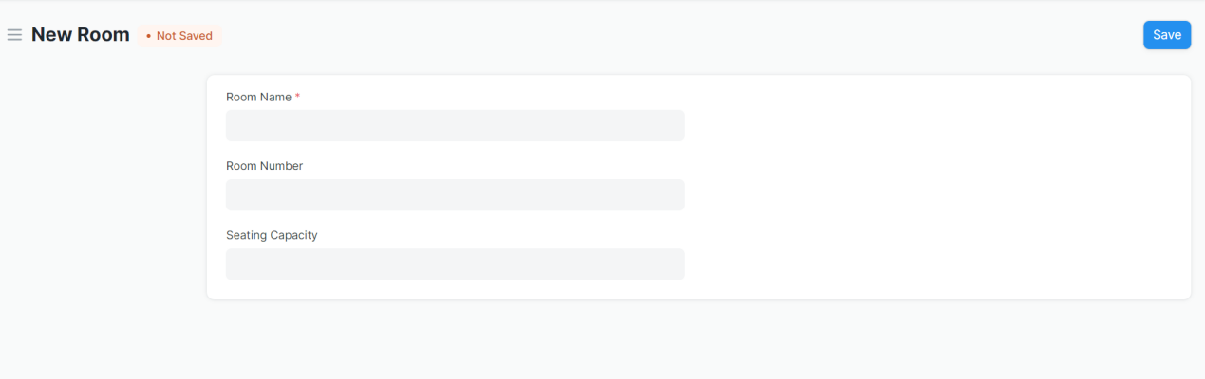
Figure 9 : Class Room Screen

Field List

The following table describes the UI fields present in this screen :
ID | Label | Type | Mandatory | Remarks | R= Rename  N= New  D= Delete
1 | Room Name | Text | Yes
2 | Room Number | Text
3 | Seating Capacity | Text

User: Roles & Permission

The following table describes the users and their roles and permissions for the screens :

ID | Role | Select | Read | Write | Create | Delete | Submit
1 | Admin | Yes | Yes | Yes | Yes | Yes | Yes
2 | Instructor | Yes | Yes | No | No | No | No

1.10 Student Admission

General Description

The following table describes overall information about this screen:
Description | Student Admission is a document which can be configured to initiate an admission Process for user by publishing it on the Institute website.
Navigation | Home > Admission > Application & Enrollment > Student Admission
Pre-requisites | - Academic Calendar  - Course Grade  - Course  - Semester  - Academic Year  - Academic Term  - Counselling Structure  - Seat Reservation Type  - Document Template  - Student Category  - Eligibility Parameter
Existing Screen Name | Student Admission
New Screen Name | No change

Screenshot

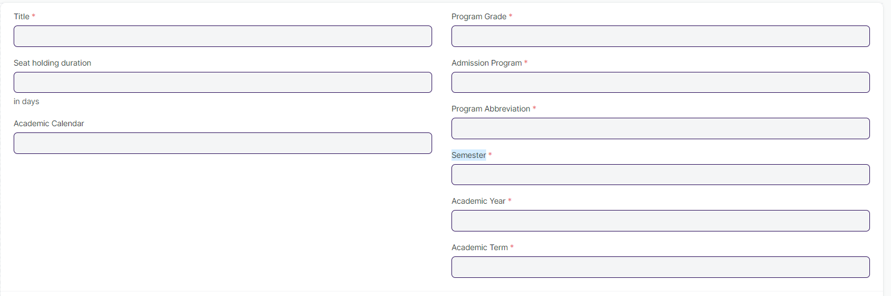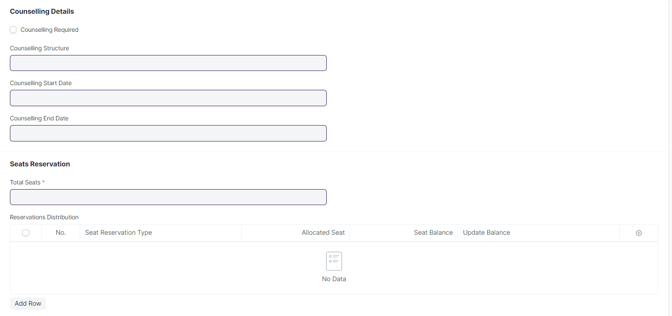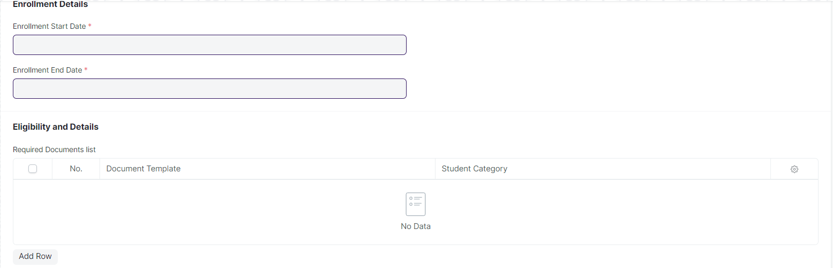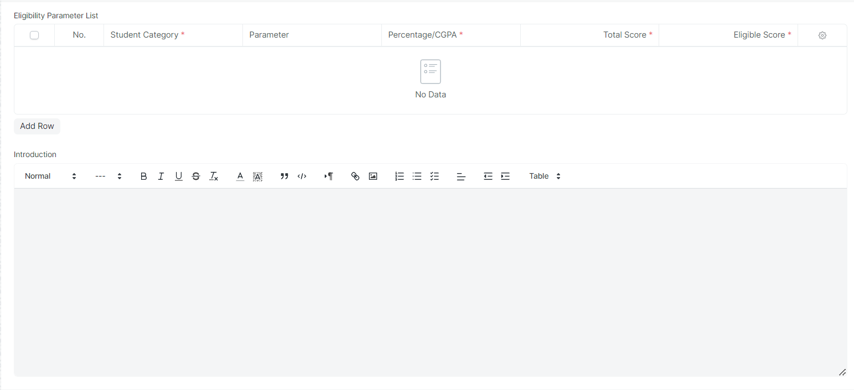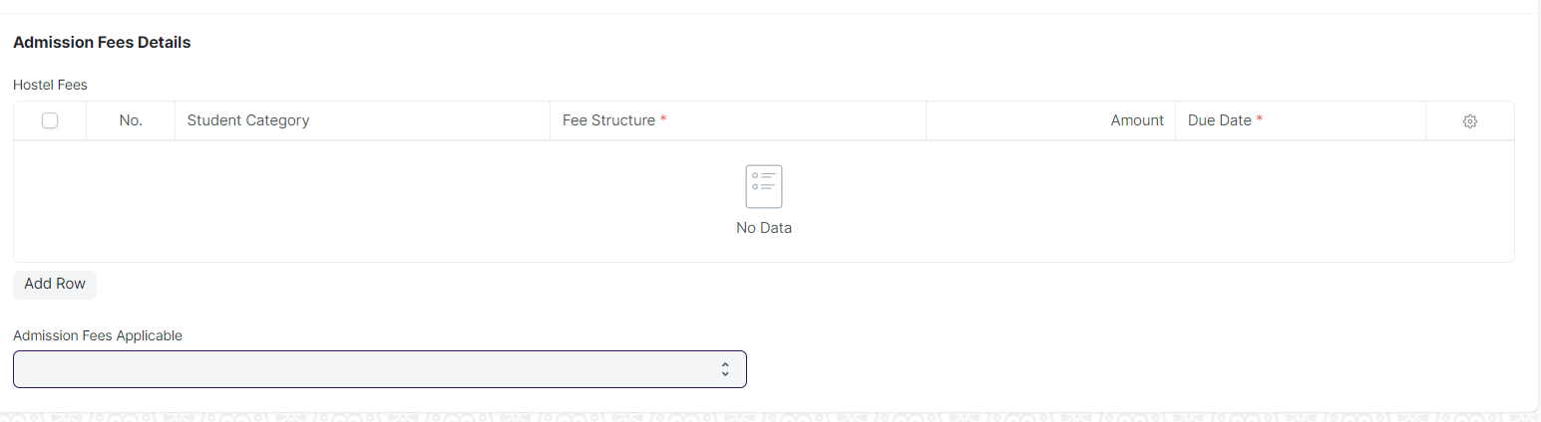
Figure 10 : Student Admission Screen

Field List

The following table describes the UI fields present in this screen :

ID | Label | Type | Mandatory | Validation / Action | Remarks | R= Rename  N= New  D= Delete
1 | Title | Text | Yes
2 | Seat holding duration | Number
3 | Academic Calendar | Link Field |  | Link Fields to master screen Academic Calendar
4 | Program Grade | Link Field |  | Link Fields to master screen Program Grade |  | ( R ) Course Grade
5 | Admission Program | Link Field | Yes | Link Fields to master screen Programs and need to be filtered on the basis of Program Grade |  | ( R ) Admission Course
6 | Program Abbreviation | Text | Yes |  |  | ( R ) Course Abbreviation
7 | Semester | Link Field | Yes | Link Fields to master screen Semester and need to be filtered on the basis of Programs
8 | Academic Year | Link Field | Yes | Link Fields to master screen Academic Year
9 | Academic Term | Link Field | Yes | Link Fields to master screen Academic Term, and need to be filtered on the basis of Academic Year
10 | Counselling Required | Checkbox |  | If Checked then counselling Structure field will be mandatory
11 | Counselling Structure | Link Field |  | Link Fields to master screen Counselling Structure
12 | Counselling Start Date | Date |  | Start date need to be before End date
13 | Counselling End Date | Date |  | End date need to be greater then start date
14 | Admission Start Date | Date |  | Start date need to be before End date
15 | Admission End Date | Date |  | End date need to be greater then start date
16 | Total Seats | Number | Yes
17 | Reservations Distribution | Child Table |  | Description of child table is in below
18 | Enable Admission Application | Checkbox
19 | Enrollment Start Date | Date | Yes | Start date need to be before End date
20 | Enrollment End Date | Date | Yes | End date need to be greater then start date
21 | Eligibility and Details | Child Table |  | Description of child table is in below
22 | Required Documents list | Child Table |  | Description of child table is in below
23 | Eligibility Parameter List | Child Table |  | Description of child table is in below
24 | Hostel Fees | Child Table |  | Description of child table is in below
25 | Counselling Fees Applicable | Dropdown |  | Yes  No
26 | Admission Fees Applicable | Dropdown |  | Yes  No
27 | Admission Fee Structure | Child Table |  | Table will be visible when user entered Yes in Admission Fees Applicable dropdown

Reservations List
ID | Label | Type | Mandatory | Validation / Action | Remarks | R= Rename  N= New  D= Delete
1 | Seat Reservation Type | Link Field |  | Link Field to Seat Reservation Type Screen | Link Fields to Seat Reservation Type screen
2 | Allocated Seat | Number
3 | Seat Balance | Number
4 | Update Balance | Button |  | Button Description is in below

Update Balance (popup)
ID | Label | Type | Mandatory | Validation/ Action | Remarks | R= Rename  N= New  D= Delete
1 | Type | Dropdown |  | Add Balance  Deduct Balance
2 | No. Of Seat | Number
3 | Update | Button |  | On click no. of seat deducted or updated w.r.t Type | Need to be Auto Update d when Program Enrollment record Submitted or Cancelled.

Student Admission Program
ID | Label | Type | Mandatory | Remarks | R= Rename  N= New  D= Delete
1 | Programs | Link Field |  | Link Fields to programs screen | Course
2 | program | Link Field |  | Link Fields to semester screen | Semester
3 | min_age | Number | Min_age should not be less then 0
4 | max_age | Number | Min_age should not be greater then 100
5 | description | Small Text
6 | application_fee | Currency
7 | applicant_naming_series | Text

Required Documents
ID | Label | Type | Mandatory | Remarks
1 | Document Template | Link Field |  | Link Fields to master screen Document Template
2 | Student Category | Link Field | Auto fetch the student category when document template entered | Link Fields to master screen Student Category

Eligibility Parameter List
ID | Label | Type | Mandatory | Remarks
1 | Student Category | Link Field | Yes | Link Fields to master screen Student Category
2 | Parameter | Link Field |  | Link Fields to master screen Eligibility Parameters
3 | Percentage/CGPA | Dropdown | Yes
4 | Total Score | Float | Yes
5 | Eligible Score | Float | Yes

Fee Structure Item
ID | Label | Type | Mandatory | Remarks
1 | Student Category | Link Field |  | Link Fields to Student Category screen
2 | Fee Structure | Link Field | Yes | Link Fields to Fee Structure screen
3 | Amount | Currency
4 | Due Date | Date | Yes

User: Roles & Permission

The following table describes the users and their roles and permissions for the screens :

ID | Role | Select | Read | Write | Create | Delete | Submit | Cancel | Amend
1 | Admin | Yes | Yes | Yes | Yes | Yes | NA | NA | NA

1.11 Student Applicant

General Description

The following table describes overall information about this screen:
Description | - A Student Applicant record gets created when a student applies to your institute for admission.  - You can Approve or Reject a student applicant. By accepting a student applicant you can add them to the student master.
Navigation | Home > Education > Admission > Student Applicant
Pre-requisites | Student Admission

Screenshot

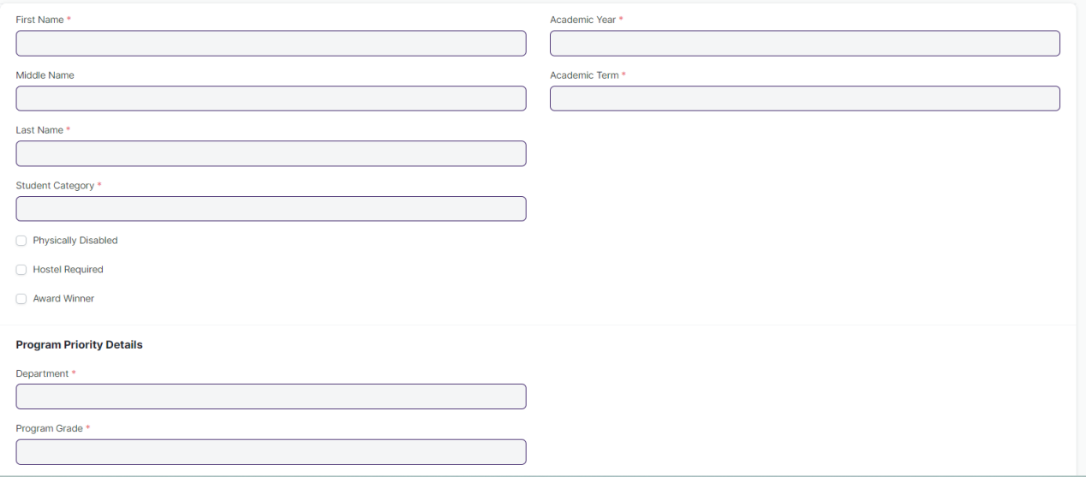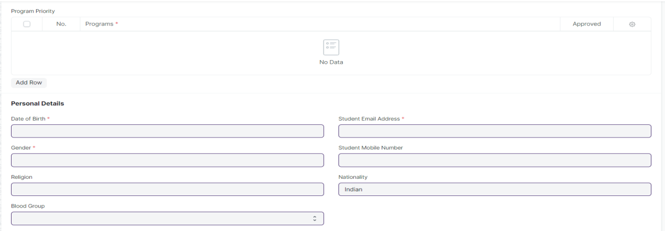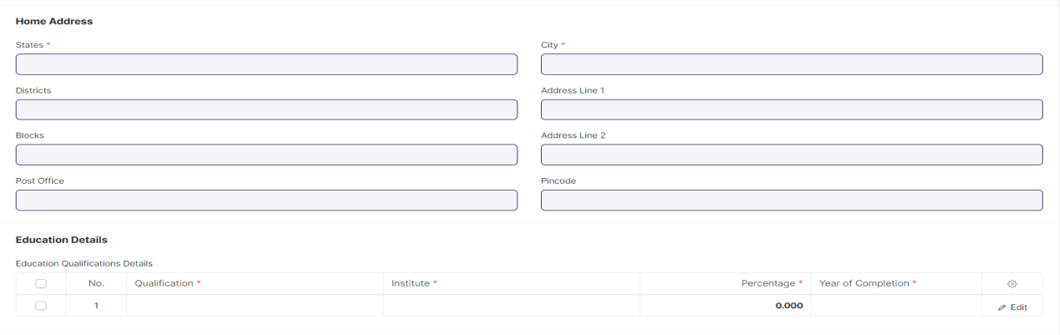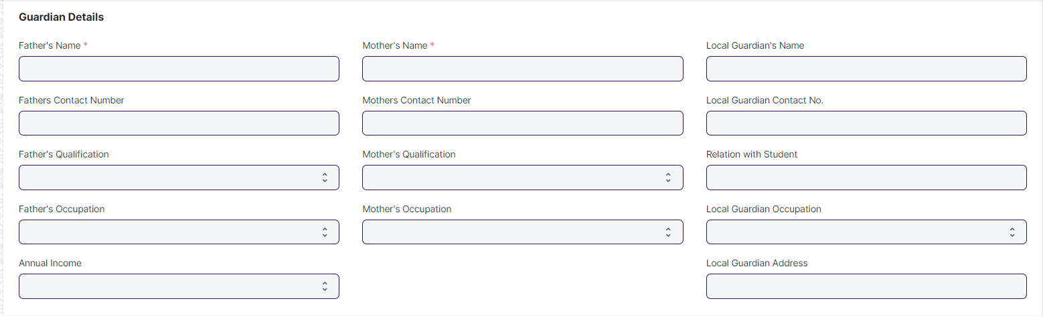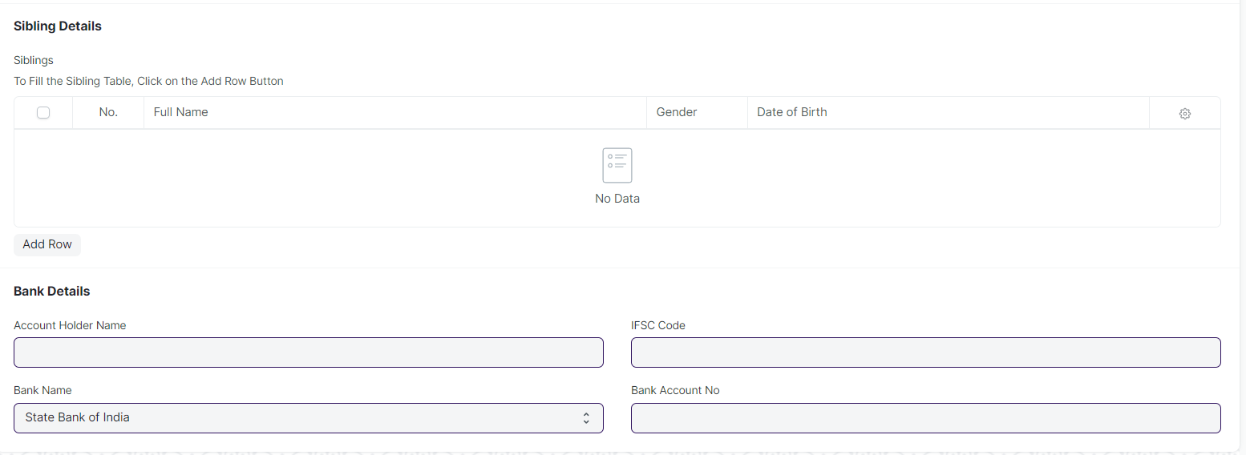
Figure 11 : Student Applicant screen

Field List

The following table describes the UI fields present in this screen :

ID | Label | Type | Mandatory | Action / Validation | Remarks | R= Rename  N= New  D= Delete
1 | First Name | Text | Yes
2 | Middle Name | Text
3 | Last Name | Text | Yes
4 | Student Category | Link Field |  | Link Fields to master screen Student Category
5 | Physically Disabled | Checkbox
6 | Physically Disabled | Table |  |  | Table will show based upon the Physically Disabled Check box
7 | Disability Type | Text | Yes
8 | Percentage of Disability | Number | Yes
9 | 窗体顶端  Attach Disability Certificate Attach | Attach | Yes | - On attachment a dialogue box will be popup where user can attach the files, take the picture with the help camera and can link any URL.  - If photos or images attached then the size will be maximum 200 kb.
10 | Hostel Required | Checkbox
11 | Award Winner | Checkbox
12 | Awards Winner List | Table |  |  | Table will show based upon the Award Winner Check box
13 | Awards | Link Field |  | Links Field to Award Screen
14 | Won in Year | Text
15 | Application Status | Dropdown |  | This dropdown will be visible after the student submitted his/her form. For Student Role It will be read only but admin can change the application status. | Applied  Approved  On Hold
16 | Application Date | Date |  | Date Will take by default today's date as read only for the student applicant role but admin can edit it.
17 | Academic Year | Link Field | Yes | Link Fields to master screen Program
18 | Academic Term | Link Field | Yes | Link Fields to master screen Program
19 | Program Priority Details | Label |  |  |  | ( R ) Course Priority Details
20 | Department | Link Field |  | Link Fields to master screen Department | Need to add a Provision for both SOS & SOE
21 | Program Grade | Link Field |  | Link Fields to master screen Program Grade |  | ( R ) Course Grade
Program Priority
22 | Program | Link Field | Yes | Programs will come in drop down with respect to the entered departments and Program Grade |  | ( R ) Course
23 | Approve | Checkbox |  | It will show only to the approving authorized user to approve the student applicant for a particular program.
Hostel Details
24 | Room Type | Link Field |  | Link Fields to master screen Room
25 | Sharing | Select
26 | Personal Details | Label
27 | Date of Birth | Date | Yes | Age need to be validated according to the age criteria will be given by WSC
28 | Gender | Dropdown | Yes | Male  Female  Other
29 | Religion | Link Field |  | Link Fields to master screen Religion
30 | Blood Group | Dropdown | Yes | A +ve  B +ve  AB +ve  O +ve  A -ve  B -ve  AB -ve  O -ve
31 | Student Email Address | Text | Yes | Auto fetched when Student applicant user will apply
32 | Student Mobile Number | Text | Yes | Mobile number should restrict to 10 digit
33 | Nationality | Text
Home Address
34 | States | Link Field | yes | Link Fields to master screen States
35 | Districts | Link Field | Yes | Link Fields to master screen Districts and filtered w.r.t State
36 | Blocks | Link Field | Yes | Link Fields to master screen Blocks and filtered w.r.t Districts
37 | Post Office | Text
38 | Address Line 1 | Text | Yes
39 | Address Line 2 | Text
40 | Pincode | Data |  | Need to be restricted upto 6 digit
41 | City | Text |  |  |  | ( R ) City/ Town / Village
42 | Education Details | Label
Education Qualifications Details |  |  |  |  | After entering the program priorities, Education Qualifications Details can only be filled
43 | Qualification | Link Field | Yes | Eligibility Parameter (From Student Admission) will auto fetch when program priority is selected
44 | Institute | Text
45 | Board | Dropdown |  | Board will be visible differently on the basis of entered qualification | For 10th-BSE,CBSE  For 12th - CHSE,BSE  For other board will be customized
46 | Percentage/ CGPA | Dropdown
47 | Total Marks | Number
48 | Earned Marks | Number |  | Earned marks need to be smaller then Total Marks
49 | Percentage | Float |  | Percentage will auto calculate on the basis of Total Marks and Earned Marks
50 | Year of Completion | Link Field |  | Link Fields to Academic Year Screen
51 | Documents Required | Label
52 | Document List | Table |  |  | Document list table will be visible after the applicant save the record.
53 | Father's Name | Text | Yes
54 | Fathers Contact Number | Text |  | Mobile number should restrict to 10 digit
55 | Father's Qualification | Dropdown
56 | Father's Occupation | Dropdown
57 | Father's Annual Income | Currency
58 | Fathers Occupation | Text
59 | Annual Income | Dropdown
60 | Mother's Name | Text
61 | Mothers Contact Number | Text |  | Mobile number should restrict to 10 digit
62 | Mother's Qualification | Dropdown
63 | Mother's Occupation | Dropdown
64 | Mother's Annual Income | Currency
65 | Local Guardian's Name | Text
66 | Local Guardian Contact No. | Text |  | Mobile number should restrict to 10 digit
67 | Relation with Student | Text
68 | Local Guardian Occupation | Dropdown
69 | Local Guardian Address | Text
Sibling Details
70 | Alumni | Checkbox
71 | Full Name | Text
72 | Contact Number | Number |  | - Contact Number will only visible if Alumni is checked.  - Mobile number should restrict to 10 digit
73 | Gender | Dropdown |  | Male  Female  Transgender
74 | Academic Year | Text
75 | Program Name | Text
76 | Date of Birth | Date
77 | Student Roll Number | Text |  | Student Roll Number will only visible if Alumni is Unchecked
78 | Title | Text |  | Read only field and automatic concatenate the first name and last name of the student applicant.
79 | Bank Details | Label
80 | Account Holder Name | Text
81 | Bank Name | Select |  | SBI  Union Bank  Other  So on……..
82 | Bank Nam | Text |  | Bank Nam will come only when a user select “Other” as Bank Name
83 | Account Type | Link Field |  | Link Fields to master screen Bank Account Type
84 | IFSC Code | Text
85 | Bank Account No | Text
86 | Exam District | Link Field | Yes | Links to District Screen
87 | Exam City/Town/Village | Link Fiekd | Yes | Links to Block Screen and filtered applied w.r.t Districts
88 | Exam Center | Text | Yes
 | Action Button |  |  | Only visible to Approving authorized user for a submitted record.
 | Approve |  |  | It will show in Action Button On Approved, the student applicant record will auto create in Student screen having all the field data auto fetched in student screen.
 | Reject |  |  | The Form is in Rejected Status, no further transaction made regarding rejected student applicant.
 | Enroll |  |  | Only visible after a record has been approved & by clicking this button, it will redirect the Program Enrollment Screen and fetched the respective fields from Student Applicant

User: Roles & Permission

The following table describes the users and their roles and permissions for the screens :
ID | Role | Select | Read | Write | Create | Delete | Submit | Cancel | Amend
1 | Student Applicant | Yes | Yes | Yes | Yes | No | Yes | No | No
2 | Student | No | No | No | No | No | No | No | No
3 | Student | Yes | Yes | Yes | No | No | NA | NA | NA

1.12 Program Enrollment

General Description

The following table describes overall information about this screen:
Description | - Program Enrollment is the record of enrollment of a student in a given program and chosen courses for a particular Academic Term.  - To ensure that students are associated with a particular program in the system, their Program Enrollment must be created. The mandatory course in that program is automatically filled in the Enrolled Courses table while the elective or optional courses can be selected manually.  - If the student has applied online for the admission in a particular Program and the application is approved, then the Program Enrollment can be created from within the Student Applicant record via clicking on the Enroll button.
Navigation | Home > Education > Admission > Program Enrollment
Pre-requisites | Student  Fee Structure  Student Batch
Existing Screen Name | Program Enrollment
New Screen Name | Course Enrollment

Screenshot
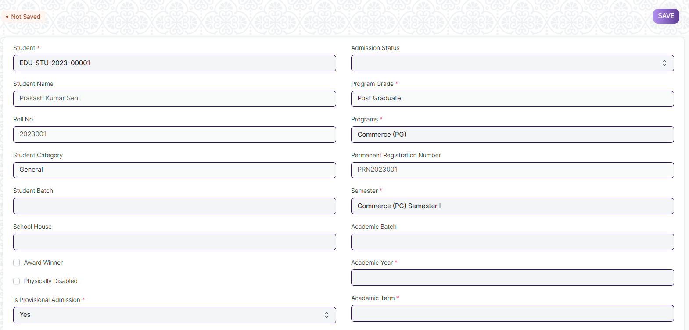
Figure 12 : Program Enrollment Screen

Field List

The following table describes the UI fields present in this screen :

ID | Label | Type | Mandatory | Validation / Action | R= Rename  N= New  D= Delete
1 | Student | Link Field | Yes | Link Fields to master screen Student, auto fetched when clicked enrolled button from student or student Applicant screen.
2 | Student Name | Read Only |  | Auto fetched when student id is inputted.
3 | Roll No | Text
4 | Gender | Link Field |  | Link Fields to master screen Gender, auto fetched when clicked enrolled connection button from student screen or enroll button from student applicant screen.
5 | Student Category | Link Field |  | Link Fields to master screen Student Category, auto fetched when clicked enrolled connection button from student screen or enroll button from student applicant screen
6 | Student Batch | Link Field |  | Link Fields to master screen Student Batch Name
7 | School House | Link Field |  | Link Fields to master screen School House
10 | Physically Disabled | Checkbox
12 | Is Provisional Admission | Dropdown | Yes | Yes  No
14 | Admission Status | Dropdown |  | Provisional Admission  Admitted
16 | Program Grade | Link Field |  | Link Fields to master screen Program Grade | ( R ) Course Grade
17 | Programs | Link Field |  | Link Fields to master screen Programs and filtered on the basis of program grade | ( R ) Courses
18 | Permanent Registration Number | Text
19 | Program | Link Field | Yes | Link Fields to master screen Semester and filtered on the basis of programs | ( R ) Semester
20 | Academic Batch | Text |  |  | (D)
21 | Academic Year | Link Field | Yes | Link Fields to master screen Academic Year auto fetched when clicked enrolled connection button from student screen. And enroll button form student applicant screen.
22 | Academic Term | Link Field |  | Link Fields to master screen Academic Term
23 | Year End Date | Date
24 | Enrollment Date | Date | Yes
25 | Seat Reservation Type | Link Field |  | Link Fields to master screen Seat Reservation Type and fetched on the basis student category wise seat reservation
26 | Available seats | Number |  | Auto fetched from Student admission screen child table Reservation distribution table.
27 | Boarding Student | Checkbox
Enrolled courses
29 | Courses | Table |  | Description of the table is given below | ( R ) Modules
Transportation
31 | Mode of Transportation
32 | Vehicle/Bus Number
34 | Due Date | Date
35 | Fee Structure Item | Table |  | - Once program enrollment record submitted for a particular student then in back-end the fees record for that particular student will created and then the student need to pay their fees from the Fees screen.  2. Description of this table is given below.
37 | Image | Attach Image |  | - On attachment a dialogue box will be popup where user can attach the images, take the picture with the help camera.  - If photos or images attached then the size will be maximum 200 kb.
38 | Academic Calendar | Table |  | Description of this table is given below.
42 | Voucher No. | Data
43 | Company | Data
44 | Submit |  |  | On submit the record the course enrollment auto created and student will be enrolled on those courses which are present in course child table

Program Enrollment Course
ID | Label | Type | Mandatory | Remarks | R= Rename  N= New  D= Delete
1 | Course | Link Field | Yes | Link Fields to master screen Course, and those courses will be visible which are linked with inputted semester | ( R ) Module
2 | Course Code | Text |  |  | ( R ) Module Code
3 | Course Name | Text |  |  | ( R ) Module Name
4 | Instructor | Link Field |  | Link Fields to master screen Instructor | ( R ) Trainer
5 | Credit Allocation | Button |  |  | ( D )

Fee Structure Item
ID | Label | Type | Mandatory | Remarks
1 | Student Category | Link Field |  | Link Fields to master screen Student Category
2 | Fee Structure | Link Field | Yes | Link Fields to master screen Fee Structure
3 | Amount | Currency
4 | Due Date | Date | Yes

Academic Calendar
ID | Label | Type | Mandatory | Remarks
1 | Academic Events | Link Field | Yes | Link Fields to master screen Academic Events, events will fetch w.r.t Academeic Calendar Template
2 | Start Date | Date | Yes | Start date will fetch w.r.t Academeic Calendar Template
3 | End Date | Date | Yes | End date will fetch w.r.t Academeic Calendar Template
4 | Duration | Number |  | Duration will fetch w.r.t Academeic Calendar Template

User: Roles & Permission

The following table describes the users and their roles and permissions for the screens :
ID | Role | Select | Read | Write | Create | Delete | Submit | Cancel | Amend
1 | Admin | Yes | Yes | Yes | Yes | Yes | Yes | Yes | Yes
2 | Instructor | Yes | Yes | No | No | No | No | No | No
3 | Student | Yes | Yes | No | No | No | No | No | No

1.13 Course Enrollment

General Description

The following table describes overall information about this screen:

Description | - Course Enrollment is the record of enrollment of a student in a given program and chosen courses for a particular Academic Term.  - To ensure that students are associated with a particular program in the system, their Course Enrollment must be created/auto-generated. The mandatory course in that program is automatically filled in the Enrolled Courses table while the elective or optional courses can be selected manually.  - If the student has applied online for the admission in a particular Program and the application is approved, then the Course Enrollment is auto-created from within the Program Enrollment record.
Navigation | Home > Admission > Application & Enrollment > Course Enrollment
Pre-requisites | Program Enrollment
Existing Screen Name | Course Enrollment
New Screen Name | Module Enrollment

Screenshot
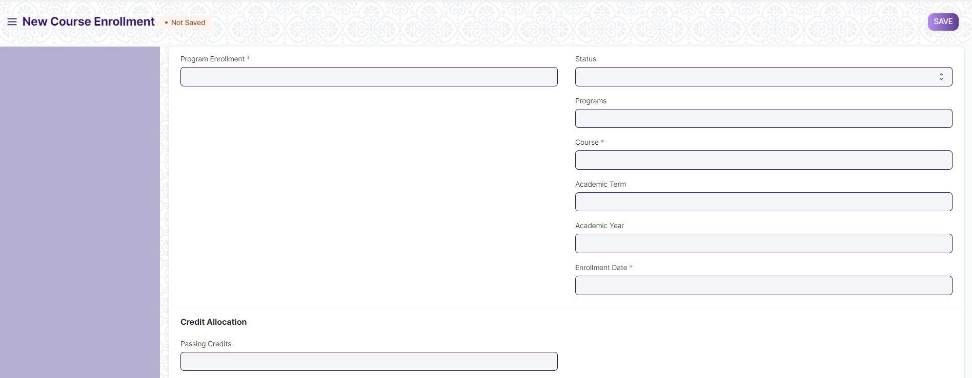
Figure 13 : Course Enrollment Screen

Field List

The following table describes the UI fields present in this screen :

ID | Label | Type | Mandatory | Remarks | R= Rename  N= New  D= Delete
1 | Program Enrollment | Link Field | Yes | Link Fields to the master screen Program Enrollment | ( R ) Course Enrollment
2 | Student | Link Field | Yes | Link Fields to the master screen Student
3 | Student Name | Text
4 | Roll No | Text
5 | Registration Number | Text
6 | Status | Dropdown
7 | Programs | Link Field |  | Link Fields to the master screen Programs | ( R ) Course
8 | Semester | Link Field |  | Link Fields to the master screen Program
9 | Course | Link Field | Yes | Link Fields to the master screen Course | ( R ) Module
10 | Course Name | Text |  |  | ( R ) Module Name
11 | Course Code | Text |  |  | ( R ) Module Code
12 | Academic Term | Link Field |  | Link Fields to the master screen Academic Term
13 | Academic Year | Link Field |  | Link Fields to the master screen Academic Year
14 | Enrollment Date | Date | Yes
15 | Credit Allocation | Label |  |  | (D)
16 | Total Credits | Float |  |  | (D)
17 | Passing Credits | Float |  |  | (D)
18 | Credit distribution | Table
19 | Grading Scale | Link Field |  | Link Fields to the master screen Grading Scale
20 | Total Course Marks | Float |  |  | ( R ) Total Module Marks
21 | Course Passing Marks | Float |  |  | ( R ) Module Passing Marks

Credit Distribution List
ID | Label | Type | Mandatory | Remarks | R= Rename  N= New  D= Delete
1 | Assessment Criteria | Link Field | Yes | Link Fields to master screen Assessment Criteria
2 | Weightage | Percent | Yes | Weightage need to be maximum 100
3 | Credits | Float | Yes |  | (D)
4 | Passing Credits | Float | Yes |  | (D)
5 | Total Marks | Float | Yes
6 | Passing Marks | Float | Yes

Topic
ID | Label | Type | Mandatory | Remarks | R= Rename  N= New  D= Delete
1 | Topic | Link Field | Yes | Link Fields to master screen Topic, and auto fetched from the course screen, w.r.t the course field data. | ( R ) Sub Module
2 | Topic Name | Text | Yes | auto fetched from the course screen, w.r.t the course field data. | ( R ) Sub Module Name
3 | Duration | Time | Yes | auto fetched from the course screen, w.r.t the course field data.
4 | Description | Long Text | Yes | auto fetched from the course screen, w.r.t the course field data. | (N)
5 | Attachment | Attach |  | - auto fetched from the course screen, w.r.t the course field data.  - On attachment a dialogue box will be popup where user can attach the files, take the picture with the help camera and can link any URL.  - If photos or images attached then the size will be maximum 200 kb.

User: Roles & Permission

The following table describes the users and their roles and permissions for the screens :

ID | Role | Select | Read | Write | Create | Delete | Submit | Cancel | Amend
1 | Admin | Yes | Yes | Yes | Yes | Yes | NA | NA | NA
2 | Student | No | Yes | No | Yes | No | NA | NA | NA
3 | Instructor | No | Yes | No | No | No | NA | NA | NA

1.14 Fee Category

General Description

The following table describes overall information about this screen:
Description | Fee Category would form all the components for calculation of Fees or creation of Fee Structure.
Navigation | Home > Admission > Fees > Fee Category
Pre-requisites

Screenshot

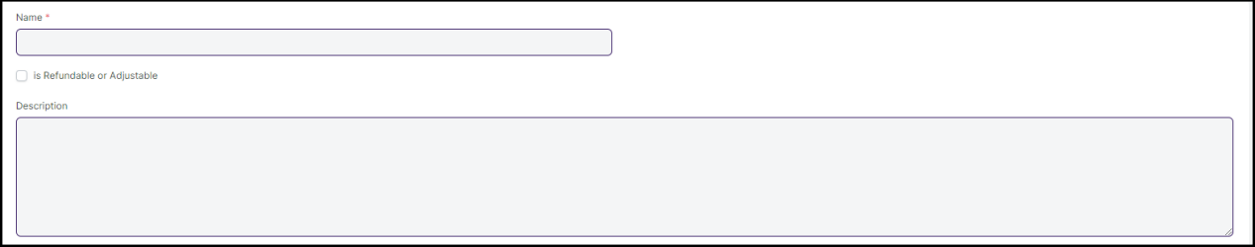
Figure 14 : Fee Category Screen

Field List

The following table describes the UI fields present in this screen :

Sl No. | Field name | Field type | Mandatory | Action /Validation
1 | Category Name | Text | Yes
2 | Description | Long Text

User: Roles & Permission
The following table describes the users and their roles and permissions for the screens:

ID | Role | Select | Read | Write | Create | Delete | Submit | Cancel | Amend
1 | Student | Yes | Yes | Yes | Yes | Yes | NA | NA | NA

1.15 Fee Structure

General Description

The following table describes overall information about this screen:
Description | A Fee Structure is a template that can be used while making Fees records or generating them via the Fee Schedule.
Navigation | Home > Admission > Fees > Fee Structure
Pre-requisites | - Fee Type  - Programs  - Program Grade  - Fee Type  - Student Category  - Semester  - Academic Year  - Academic Term

Screenshot

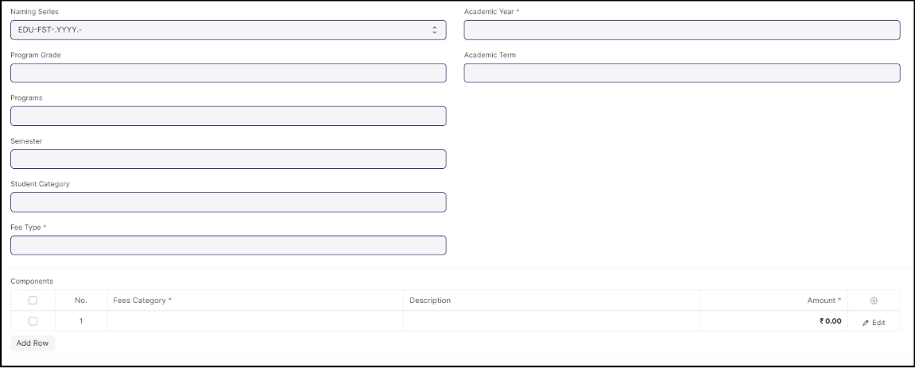
Figure 15 : Fee Structure

Field List

The following table describes the UI fields present in this screen :

ID | Label | Type | Mandatory | Remarks | R= Rename  N= New  D= Delete
1 | Is Hostel Fees | Dropdown
2 | Program Grade | Link Field | Linked to Program Grade |  | ( R ) Course Grade
3 | Programs | Link Field | Linked to Programs Screen |  | ( R ) Course
4 | Program | Link Field | Linked to Semester Screen |  | ( R ) Semester
5 | Student Category | Link Field | Linked to Student Category Screen
6 | Fee Type | Link Field | Linked to Fee Type Screen | Yes
7 | Exam Type | Link Field | Linked to Exam Type Screen
9 | Academic Year | Link Field | Linked to Academic Year Screen | Yes
10 | Academic Term | Link Field | Linked to Academic Term Screen
11 | Course Wise Fees | Table | Course Wise Fees is child table present in Fee Structure Screen
12 | Components | Table | Components is child table present in Fee Structure Screen | Yes
13 | Total Amount | Currency
14 | Receivable Account | Link Field | Linked to Receivable Account Screen | Yes
15 | Income Account | Link Field | Linked to Income Account Screen
16 | Company | Link Field | Linked to Company Screen
17 | Cost Center | Link Field | Linked to Cost Center Screen

User: Roles & Permission

The following table describes the users and their roles and permissions for the screens :

ID | Role | Select | Read | Write | Create | Delete | Submit | Cancel | Amend
1 | Admin | Yes | Yes | Yes | Yes | Yes | NA | NA | NA

1.16 Fee Schedule

General Description

The following table describe overall information about this screen:
Description | Fee Schedule would help in defining a time-line for the Fee payment of the students, based on the Student Group.
Navigation | Home > Admission > Fees > Fee Schedule
Pre-requisites | Fee Structure

Screenshot
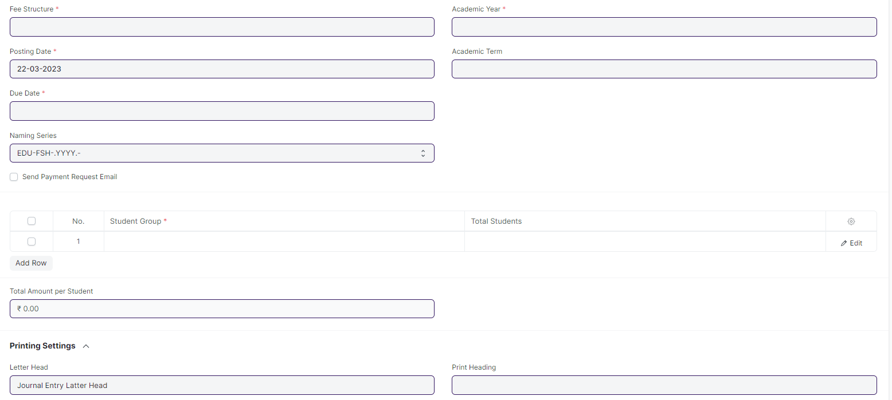
Figure 16 : Fee Schedule

Field List

The following table describes the UI fields present in this screen :

Sl No. | Field name | Field type | Mandatory | Action / Validation | R= Rename  N= New  D= Delete
1 | Fee Structure | Link Field | Yes | Link Fielded to Fee Structure Screen
2 | Posting Date | Date | Yes
3 | Due Date | Date | Yes
4 | Fee Creation Status | Dropdown |  | In Process  Failed  Successful
5 | Send Payment Request Email | Checkbox |  | If checked mail will be triggered form payment request
7 | Student Category | Link Field |  | Links to Student Category screen
8 | Programs | Link Field |  | Links to Programs Screen | ( R ) Course
9 | Program | Link Field |  | Links to Semester Screen | ( R ) Semester
10 | Academic Year | Link Field | Yes | Links to Academic Year
11 | Academic Term | Link Field |  | Links to Academic Term
13 | Currency | Link Field |  | Links to Currency Screen
14 | Student Group | Table | Yes | - filtered will be applied on the basis of inputted semester and academic term  - Description of the table given below
16 | Fee Components | Table |  | Description of the table given below
19 | Total Amount per Student | Currency
20 | Grand Total | Currency
21 | In Words | Text
23 | Letter Head | Link Field |  | Links to the Letter head screen
25 | Print Heading | Link Field |  | Links to Print Heading Screen
27 | Receivable Account | Link Field |  | Links to Receivable Account
28 | Income Account | Link Field |  | Links to Income Account
30 | Institution | Link Field |  | Links to Company Screen
32 | Cost Center | Link Field |  | Links to Cost Center Screen

User: Roles & Permission

The following table describes the users and their roles and permissions for the screens :

ID | Role | Select | Read | Write | Create | Delete | Submit | Cancel | Amend
1 | Admin | Yes | Yes | Yes | Yes | Yes | NA | NA | NA

1.17 Fees
General Description

The following table describes overall information about this screen:
Description | In this form, Fee Records of the students can be maintained.
Navigation | Home > Admission > Fees > Fees
Pre-requisites | Fee Structure  Fee Schedule

Screenshot
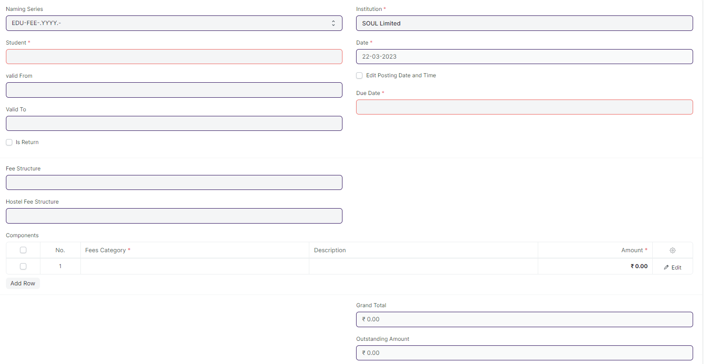
Figure 17 : Fees

Field List

The following table describes the UI fields present in this screen :

Sl No. | Field name | Field type | Mandatory | Action / Validation | R= Rename  N= New  D= Delete
1 | Student | Link Field |  | Link Field to Student Screen
2 | Student Name | Text | Yes | Student Name auto fetched when student id is entered
3 | Roll No | Text |  | Roll No auto fetched when student id is entered
4 | Registration Number | Text |  | Registration Number auto fetched when student id is entered
5 | Fee Schedule | Link Field |  | Link Field to Fee Schedule Screen
8 | valid From | Date
9 | Valid To | Date |  | Valid to date should be greater then Valid from date
11 | Return Issued | Checkbox
13 | Institution | Link Field | Yes | Link Fielded to Company Screen
14 | Date | Date | Yes
15 | Posting Time | Time
16 | Edit Posting Date and Time | Checkbox
17 | Due Date | Date | Yes
19 | Program Enrollment | Link Field |  | Link Field to Program Enrollment Screen | ( R ) Course Enrollment
20 | Programs | Link Field | Yes | Link Field to Programs Screen | ( R ) Course
21 | Semester | Link Field | Yes | Link Field to Semester Screen
22 | Student Batch | Link Field |  | Link Field to Student Batch Screen
23 | Student Email | Text |  | Auto fetched when student id is entered
25 | Student Category | Link Field |  | Link Fielded to Student Category Screen
26 | Academic Term | Link Field |  | Link Fielded to Academic Term Screen
27 | Academic Year | Link Field |  | Link Fielded to Academic Year Screen
29 | Currency | Link Field |  | Link Fielded to Currency Screen
30 | Fee Structure | Link Field |  | Link Fielded to Fee Structure Screen and filtered applied according to the Programs, Semester and Academic Term.
31 | Hostel Fee Structure | Link Field |  | Link Fielded to Hostel Fee Structure Screen
32 | Components | Table | Yes
34 | Grand Total | Currency
35 | In Words | Text
36 | Outstanding Amount | Currency
38 | Waiver Type | Drop down |  | Amount  Percentage
39 | Percentage | Text
40 | Amount | Currency
41 | Waiver Amount | Currency
43 | Letter Head | Link Field |  | Link Fielded to Letter Head Screen
46 | Print Heading | Link Field |  | Link Fielded to Print Heading Screen
48 | Receivable Account | Link Field | Yes | Link Fielded to Receivable Account Screen
50 | Return Against | Link Field |  | Link Fielded to Receivable Account
51 | Income Account | Link Field |  | Link Fielded to Income Account
53 | Cost Center | Link Field |  | Link Fielded to Cost Center
55 | Hostel Admission | Link Field |  | Link Fielded to Hostel Admission
61 | Has Program Enrollment | Checkbox
63 | Employee | Link Field |  | Link Fielded to Employee Screen
65 | Employee Name | Text |  | Auto fetched the Employee name when Employee selected

Users: Roles & Permission

The following table describes the users and their roles and permissions for the screens :

ID | Role | Select | Read | Write | Create | Delete | Submit | Cancel | Amend
1 | Admin | Yes | Yes | Yes | Yes | Yes | NA | NA | NA
2 | Student | Yes | Yes | Yes | No |  | NA | NA | NA

1.18 Student

General Description

The following table describes overall information about this screen:

Description | - The Student document will hold all the data related to the student such as their personal information, Photo, Date of Birth, Address, etc.  - This form will also contain any additional details, like the Student's Guardian and Sibling details.  - Note : The student is enrolled in a program when the application (Student Application) is approved. Once the enrollment is done, the Student Applicant status is updated to Admitted
Navigation | Home > Admission > Student & Instructor > Student
Pre-requisites

Screenshot

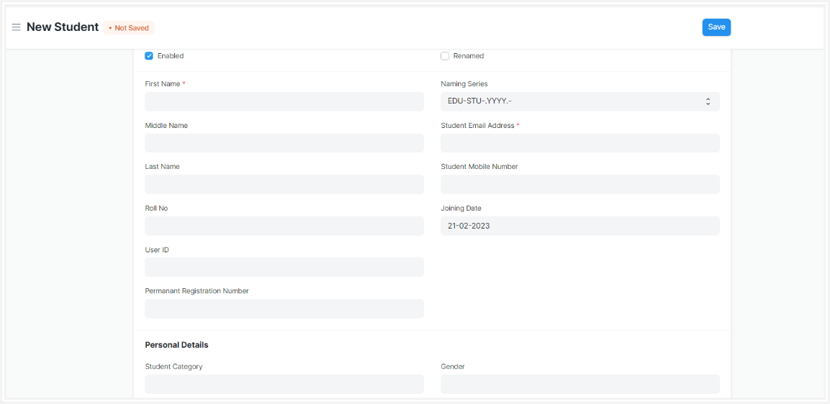
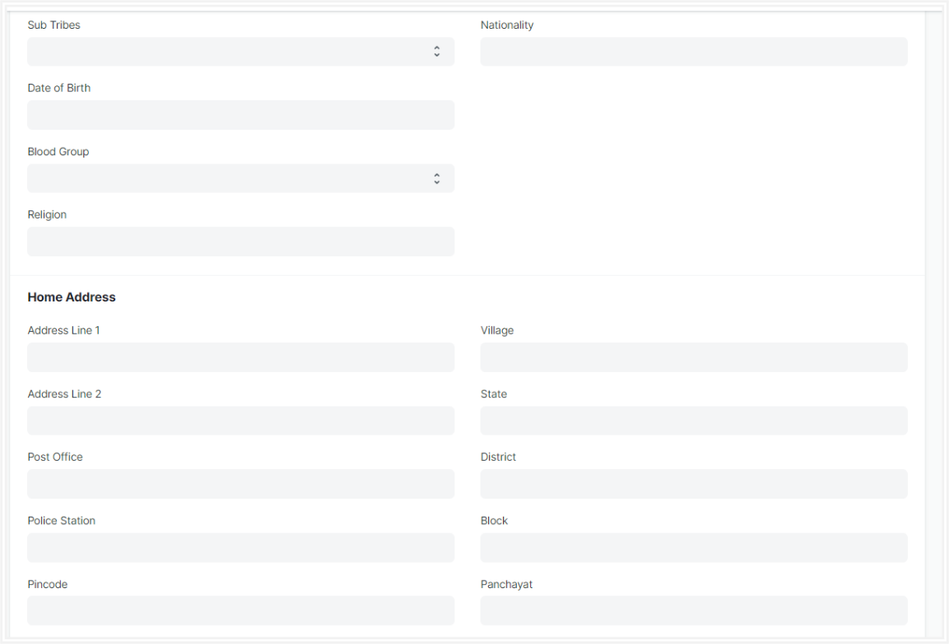
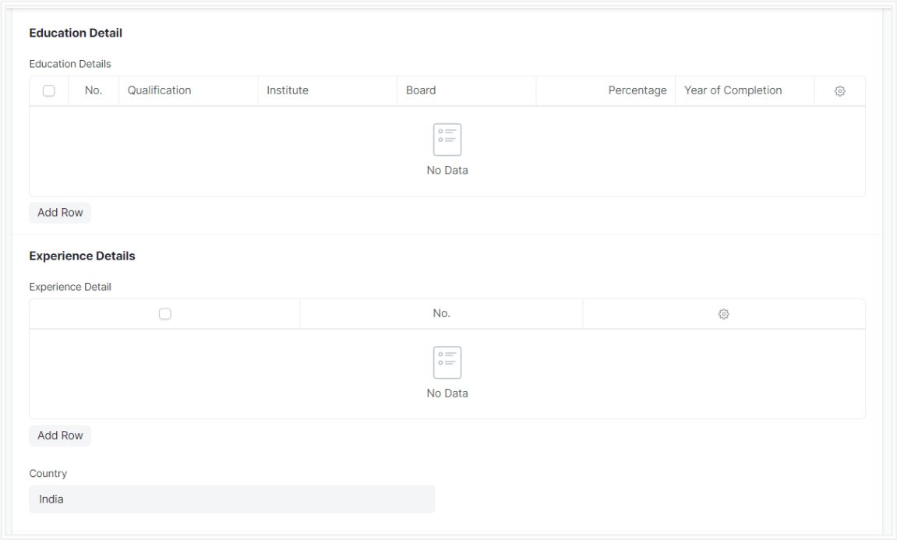
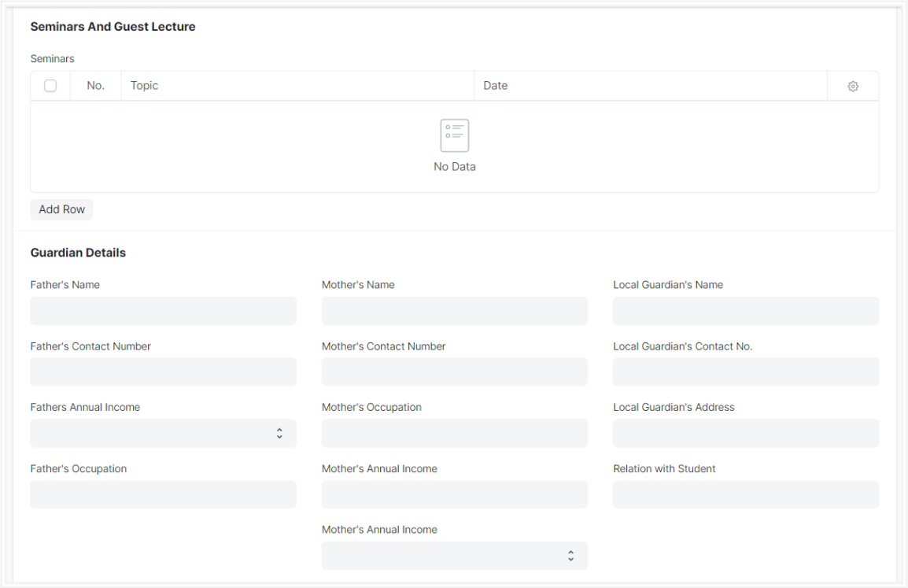
Figure 18 : Student Screen

Field List

The following table describes the UI fields present in this screen:

ID | Label | Type | Mandatory | Validation / Action | R = Rename  N= New  D= Delete
 | Enabled | Checkbox |  | Student by default would  always be enabled.  Once user have recorded  the Student's Exit Details,  user must unchecked this box to disable the student.
1 | First Name | Text | Yes
2 | Middle Name | Text
3 | Last Name | Text
4 | Roll No | Text
5 | User ID | Link Field |  | - Links to User Screen  - After Stud approvent Applicant formed, the auto fetched the User id data in student.  - If manually Student record created, the user need to entered the User Id.
6 | Permanent Registration Number | Text
7 | Naming Series | Dropdown |  | Autogenerate
8 | Student Email Address | Text |  | Need to be added Email format
9 | Student Mobile Number | Text |  | Restricted to 10 digits
10 | Joining Date | Text |  | It is By default today's date
11 | Image | Attachment |  | - On attachment a dialogue box will be popup where user can attach the files, take the picture with the help camera and can link any URL.  - If photos or images attached then the size will be maximum 200 kb.
Personal Details
12 | Student Category | Link Field |  | Links to Student Category Screen
13 | Sub Tribes | Dropdown |  | - Kond  - Gabri  - Dongri  - So on……
14 | Date of Birth | Date
15 | Blood Group | Dropdown |  | A +ve  B +ve  AB +ve  O +ve  A -ve  B -ve  AB -ve  O -ve
16 | Religion | Link
17 | Gender | Link
18 | Nationality | Text
19 | Physically Disabled | Checkbox
20 | Award Winner | Checkbox
Home Address
21 | Address Line 1 | Text
22 | Address Line 2 | Text
23 | Post Office | Text
24 | Police Station | Text
25 | Pincode | Text
26 | Village | Text
27 | State | Text
28 | District | Text
29 | Block | Text
30 | Panchayat | Text
Current Educational Details |  |  |  | Auto Updated when program enrollment record is submitted for individual Students
31 | Programs | Link Field |  | Links to Program Screen, and auto fetched from program enrollment screen | ( R ) Course
32 | Semesters | Link Field |  | Links to Semester Screen, and auto fetched from program enrollment screen
33 | Academic Year | Link Field |  | Links to Academic Year Screen, and auto fetched from program enrollment screen
34 | Academic Term | Link Field |  | Links to Academic Term Screen, and auto fetched from program enrollment screen
Education Detail
35 | Qualification | Link Field |  | Links to Eligibility Parameter Screen
36 | Institute | Text
37 | Board | Text
38 | Percentage/CGPA | Dropdown
39 | Total Marks | Number
40 | Earned Marks | Number
41 | Percentage | Float
42 | CGPA | Float
43 | Year of Completion | Text
Experience Details
44 | Company name | Text
45 | Job profile | Text
46 | Job type | Dropdown |  | - Permanent  - Internship  - Contractual  - Non-contractual
47 | Job start date | Text
48 | Job end date | Text
49 | Job duration | Text
50 | Country | Link
Seminars And Guest Lecture
51 | Topic | Text
52 | Activities | Dropdown
53 | Description | text
54 | Duration | Float
55 | Department | Link
56 | Academic Year | Link
57 | Date | Text
58 | Student Id | Text
Guardian Details
59 | Father's Name | Text
60 | Father's Contact Number | Text
61 | Fathers Annual Income | Text
62 | Father's Occupation | Text
63 | Mother's Name | Text
64 | Mother's Contact Number | Text
65 | Mother's Occupation | Text
66 | Mother's Annual Income | Text
67 | Local Guardian's Name | Text
68 | Local Guardian's Contact No | Text
69 | Local Guardian's Address | Text
70 | Relation with Student | Text
Sibling Details
71 | Full Name | Text
72 | Gender | Dropdown
73 | Date of Birth | Text
74 | Student Roll Number | Text
75 | Contact Number | Text
76 | Alumni | Checkbox
77 | Program Name | Text
78 | Academic Year | Text
Medical History
79 | Illness | Text
80 | Description | Text
81 | Attach | Attachment |  | - On attachment a dialogue box will be popup where user can attach the files, take the picture with the help camera and can link any URL.  - If photos or images attached then the size will be maximum 200 kb.
Exit
82 | Date of Leaving | Date
83 | Leaving Certificate Number | Text
84 | Reason For Leaving | Text
85 | Mentor Allocation | Link Field
Documents
86 | Document Name | Link Field
87 | Mandatory | Checkbox
88 | Attach | Attachment |  | - On attachment a dialogue box will be popup where user can attach the files, take the picture with the help camera and can link any URL.  - If photos or images attached then the size will be maximum 200 kb.

Users: Roles & Permission

The following table describes the users and their roles and permissions for the screens :
ID | Role | Select | Read | Write | Create | Delete | Submit | Cancel | Amend
1 | Admin | Yes | Yes | Yes | Yes | Yes | NA | NA | NA
2 | Student | Yes | Yes | No | No |  | NA | NA | NA
3 | Instructor | Yes | Yes | No | No |  | NA | NA | NA

1.19 Instructor

General Description

The following table describes overall information about this screen:

Description | - An instructor is a teacher, tutor, or a professor who will be responsible for teaching a particular topic or course to the students.  - This screen will be used to maintain the Instructor Log in the form of a list of topics/courses covered by the Instructor. This log will have the entire history of the courses taught by the Instructor.
Navigation | Home > Admission > Student & Instructor > Instructor
Pre-requisites | - User  - Employee  - Department  - Programs  - Semester  - Course  - Academic Year  - Academic Term

Screenshot

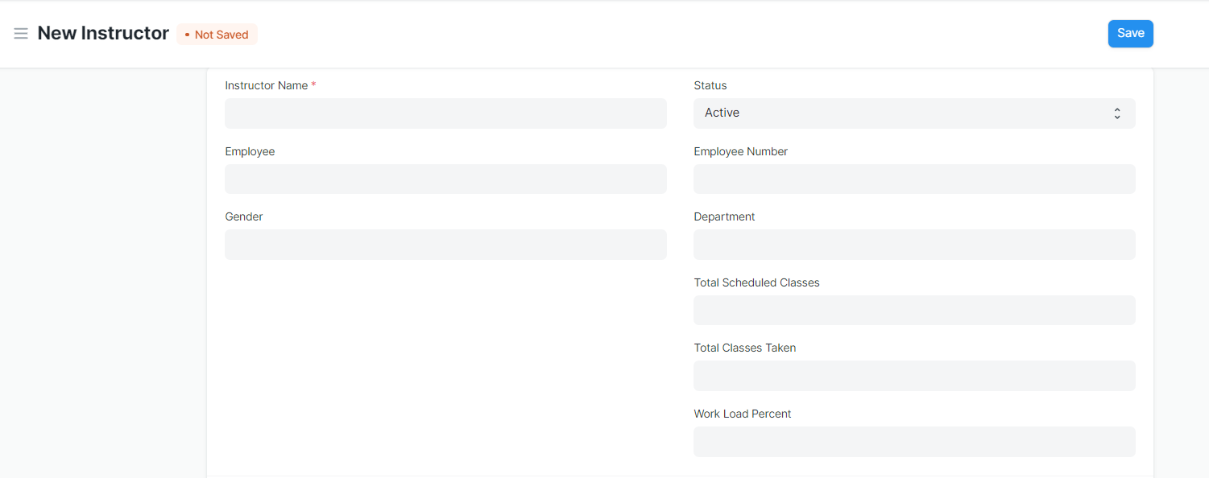
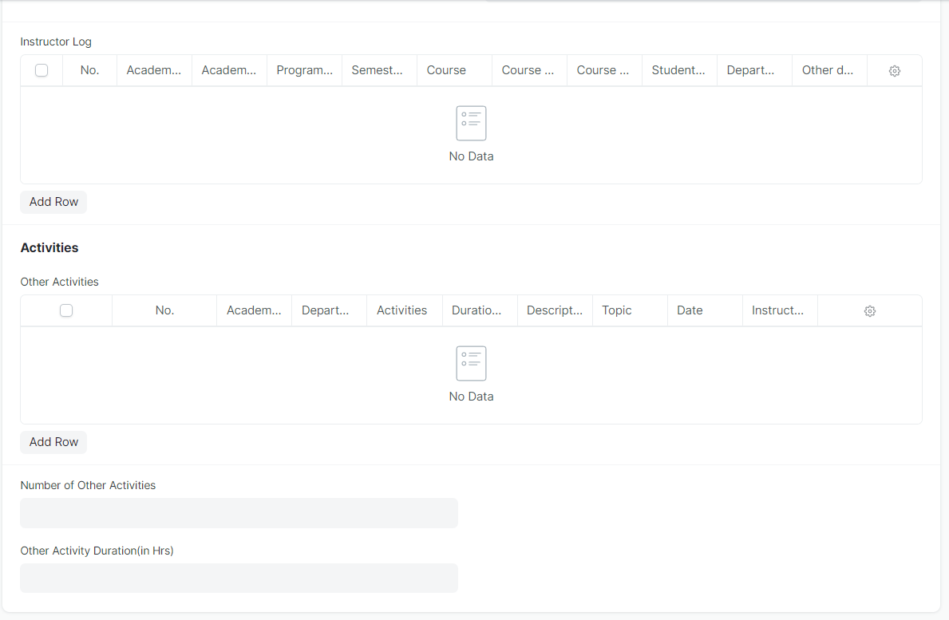
Figure 19 : Instructor Screen

Field List

The following table describes the UI fields present in this screen :

ID | Label | Type | Mandatory | Remarks | R = Rename  N= New  D= Delete
1 | Instructor Name | Text | Yes | Auto fetch the detail when employee id entered | ( R ) Trainer Name
2 | Employee | Link Field |  | Linked to Employee Screen
3 | Gender | Link Field |  | Auto fetch the detail when employee id entered
4 | Status | Dropdown
5 | Naming Series | Dropdown
6 | Employee Number | Text |  | Auto fetch the detail when employee id entered
7 | Department | Link Field |  | Auto fetch the detail when employee id entered
8 | Total Scheduled Classes | Number
9 | Total Classes Taken | Number
10 | Work Load Percent | Float
11 | Image | Attach Image |  | - On attachment a dialogue box will be popup where user can attach the image, take the picture with the help camera and can link any URL.  - If photos or images attached then the size will be maximum 200 kb.
Instructor Log
12 | Academic Year | Link Field | Yes
13 | Academic Term | Link Field |  | Academic Term is filtered on the basis of Academic Year
14 | Department | Link Field
15 | Programs | Link Field | Yes |  | ( R ) Course
16 | Semester | Link Field | Yes | Semester is filtered on the basis of Programs
17 | Course | Link Field |  | Course is filtered on the basis of semester | ( R ) Module
18 | Course code | Link Field |  | Auto fetch the detail when course entered | ( R ) Module Code
19 | Course Name | Text |  | Auto fetch the detail when course entered | ( R ) Module Name
20 | Student Group | Link Field
21 | Other details | Small Text
Activities
22 | Academic Year | Link Field |  | Linked to Academic year screen
23 | Department | Link Field |  | Linked to Department Screen
24 | Activities | Dropdown
25 | Date | Date
26 | Duration(in Hrs ) | Float
27 | Description | Long Text
28 | Topic | Text
29 | Instructor Name | Text |  |  | ( R ) Trainer Name

Users: Roles & Permission

The following table describes the users and their roles and permissions for the screens :

ID | Role | Select | Read | Write | Create | Delete | Submit | Cancel | Amend
1 | Admin | Yes | Yes | Yes | Yes | Yes | NA | NA | NA
2 | Instructor | Yes | Yes | No | No |  | NA | NA | NA

1.20 Student Re registration Tool

General Description

The following table describes overall information about this screen:
Description | Student Re registration tool mainly help for enrolling the students into their next semester bulk wise only after the enrollment of first semester.
Navigation | Home > Admission > Tools > Student Re registration
Pre-requisites | - Program Enrollment upto first semester  - Semester  - Academic Year  - Academic Term  - Student Batch

Screenshot
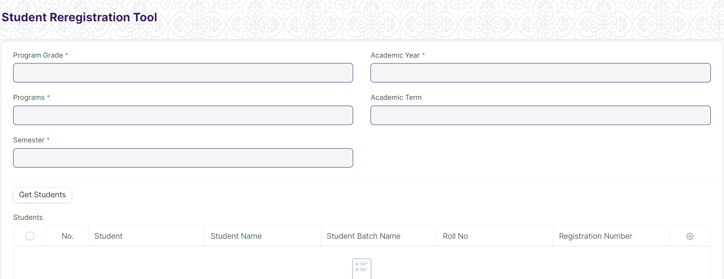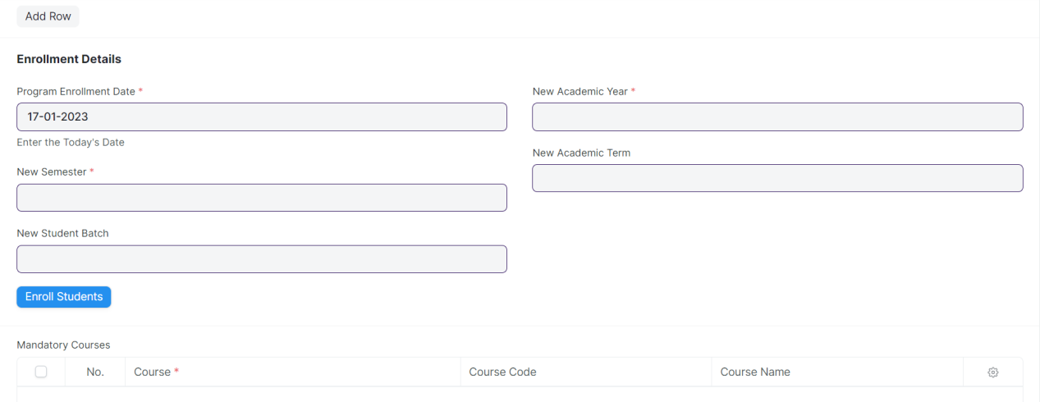
Figure 20 : Student Re registration Tool Screen

Field List:

The following table describes the UI fields present in this screen :

ID | Label | Type | Mandatory | Validation / Action | R = Rename  N= New  D= Delete
1 | Program Grade | Link Field | Yes | Linked to Program Grade Screen | ( R ) Course Grade
2 | Programs | Link Field | Yes | Linked to Programs Screen | ( R ) Course
3 | Program | Link Field | Yes | Linked to Semester Screen | ( R ) Semester
4 | Student Batch | Link Field
5 | Academic Year | Link Field | Yes | Linked to Academic Year Screen
6 | Academic Term | Link Field | Yes | Linked to Academic Term Screen
7 | Get Students | Button
8 | Students | Table |  | Auto Generated the student List
9 | Program Enrollment Date | Date | Yes | Need to give the todays date | ( R ) Course enrollment
10 | New Semester | Link Field | Yes | Linked to Semester Screen
11 | New Student Batch | Link Field | Yes
12 | Enroll Students | Button
13 | New Academic Year | Link Field | Yes | Linked to Academic Year Screen
14 | New Academic Term | Link Field | Yes | Linked to Academic Term Screen
15 | Mandatory Courses | Table
Students
16 | Student | Link Field
17 | Student Name | Text
18 | Roll Number | Text
Mandatory Courses
19 | Course | Link Field |  |  | ( R ) Module
20 | Course Name | Text |  |  | ( R ) Module Name

Users: Roles & Permission

The following table describes the users and their roles and permissions for the screens :

ID | Role | Select | Read | Write | Create | Delete | Submit | Cancel | Amend
1 | Admin | Yes | Yes | Yes | Yes | Yes | NA | NA | NA

1.21 Entrance Exam Declaration

General Description

The following table describe overall information about this screen:
Description | Entrance Exam Declaration screen shows the Department Name, Course Name, Entrance Date, Entrance Time, Description for the Entrance Examination.
Navigation
Pre-requisites | - Department Name  - Course Name  - Academic Year

Screenshot

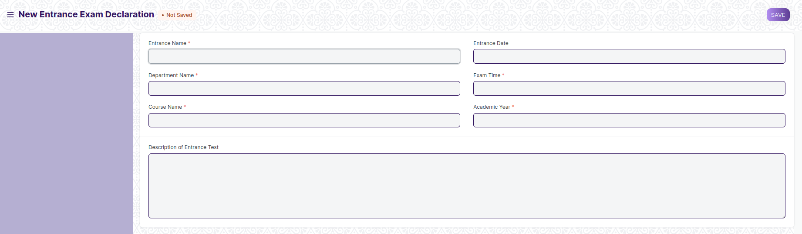
Figure 21: Entrance Exam Declaration Screen

Field List

The following table describes the UI fields present in this screen :

ID | Label | Type | Mandatory | Validation / Action | R = Rename  N= New  D= Delete
1 | Entrance Name | Text | Yes
2 | Department Name | Link Field | Yes | Linked to Department Screen
3 | Course Name | Link Field | Yes | Linked to Programs Screen | ( R ) Course
4 | Entrance Date | Date
5 | Exam Time | Time | Yes
6 | Academic Year | Link Field | Yes | Linked to Academic Year Screen
7 | Description of Entrance Test | Long Text

Users: Roles & Permission

The following table describes the users and their roles and permissions for the screens :

ID | Role | Select | Read | Write | Create | Delete | Submit | Cancel | Amend
1 | Admin | Yes | Yes | Yes | Yes | Yes | NA | NA | NA

1.22 Admit Card Issue

General Description

The following table describes overall information about this screen:

Description | Admit Card refers to the student Applicant where individual Admit card will be provided to the students applicants after entrance exam declaration having their respective exam details.
Navigation
Pre-requisites | Student Applicant  Department Name  Course Name

Screenshot

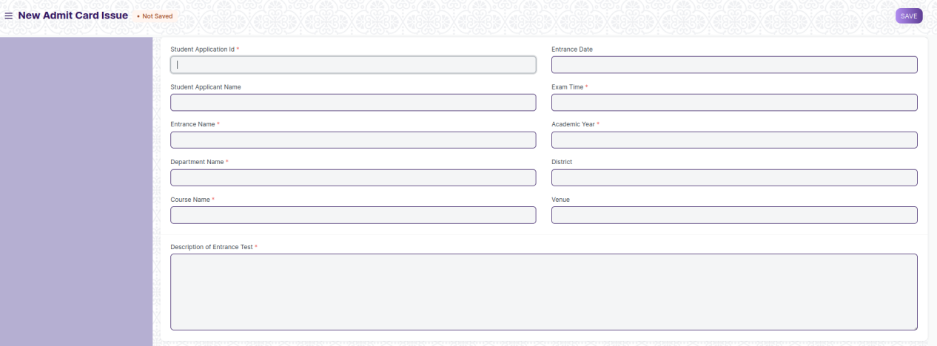
Figure 22 : Student Admit Card Screen

Field List

The following table describes the UI fields present in this screen :

ID | Label | Type | Mandatory | Validation / Action | R = Rename  N= New  D= Delete
1 | Student Application Id | Link Field | Yes | Linked to Student Applicant Screen
2 | Student Applicant Name | Text |  | Student Applicant name Auto fetch wen student applicant id is entered
3 | Entrance Name | Link Field | Yes | Linked to Entrance Exam Declaration screen
4 | Department Name | Link Field | Yes | Linked to Department Screen
5 | Course Name | Link Field | Yes | Linked to Programs Screen | ( R ) Course
6 | Entrance Date | Date
7 | Exam Time | Time | Yes
8 | Academic Year | Link Field | Yes | Linked to Academic Year Screen
9 | District | Link Field |  | Linked to District Screen
10 | Venue | Text
11 | Description of Entrance Test | Long Text | Yes

Users: Roles & Permission

The following table describes the users and their roles and permissions for the screens :

ID | Role | Select | Read | Write | Create | Delete | Submit | Cancel | Amend
1 | Admin | Yes | Yes | Yes | Yes | Yes | NA | NA | NA

1.23 Document Template

General Description

The following table describes overall information about this screen:

Description | - Document Template is a list of all the different templates required for getting admission in a particular class.  - Document Template is primarily used while creating a student admission for a class.
Navigation | Home > Admission > Admission Masters > Document Template
Pre-requisites | - Academic Year  - Student Category  - Documents

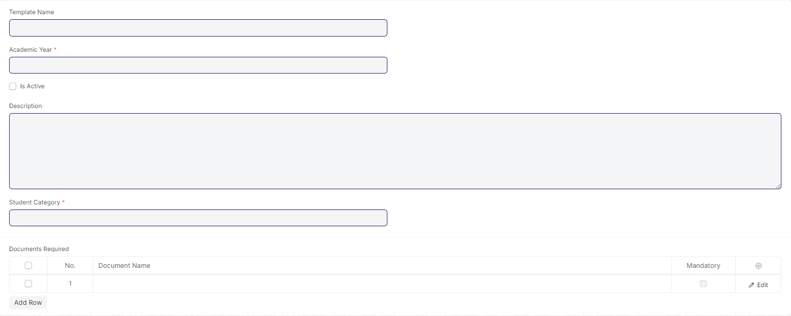
Screenshot

Field List

The following table describes the UI fields present in this screen :
ID | Label | Type | Mandatory | Validation / Action | R = Rename  N= New  D= Delete
1 | Template Name | Text
2 | Academic Year | Link Field | Yes
3 | Is Active | Checkbox | Yes
4 | Description | Small Text
5 | Student Category | Link Field |  | Student Category will be fetched from the Student Category master data.
6 | Documents Required | Table

Documents Template List
ID | Label | Type | Mandatory | Validation / Action | R = Rename  N= New  D= Delete
1 | Document Name | Link Field |  | Documents will be fetched from the Documents master data.
2 | Mandatory | Checkbox
3 | Is Available | Checkbox

Users: Roles & Permission

The following table describes the users and their roles and permissions for the screens :

ID | Role | Select | Read | Write | Create | Delete | Submit | Cancel | Amend
1 | Admin | Yes | Yes | Yes | Yes | Yes | NA | NA | NA

1.24 Academic Event

General Description

The following table describes overall information about this screen:

Description | An Academic Events are individual events which is used for creating Academic Calendar while preparing Schedule for a Class.
Navigation | Home > Admission > Admission Masters > Academic Events
Pre-requisites

Screenshot

Field List

The following table describes the UI fields present in this screen :

ID | Label | Type | Mandatory | Validation / Action
1 | Event Name | Text

Users: Roles & Permission

The following table describes the users and their roles and permissions for the screens :

ID | Role | Select | Read | Write | Create | Delete | Submit | Cancel | Amend
1 | Admin | Yes | Yes | Yes | Yes | Yes | NA | NA | NA
2 | Instructor | Yes | Yes | No | No | No | No | No | No
3 | Student | Yes | Yes | No | No | No | No | No | No

1.25 Awards

General Description

The following table describes overall information about this screen:
Description | Awards is Master Screen, you can create different types of awards such as State, National, International Awards, etc.
Navigation
Pre-requisites

Screenshot

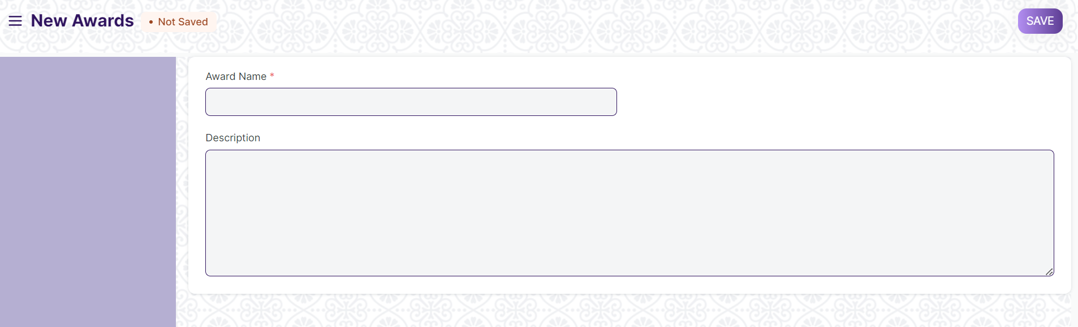

Field List:

The following table describes the UI fields present in this screen :

ID | Label | Type | Mandatory | Validation / Action
1 | Award Name | Text | Yes
2 | Description | Long Text

Users: Roles & Permission

The following table describes the users and their roles and permissions for the screens :

ID | Role | Select | Read | Write | Create | Delete | Submit | Cancel | Amend
1 | Admin | Yes | Yes | Yes | Yes | Yes | NA | NA | NA
2 | Instructor | Yes | Yes | No | No | No | No | No | No
3 | Student | Yes | Yes | No | No | No | No | No | No

1.26 Country

General Description

The following table describes overall information about this screen:
Description | Country is Master Screen, we can create different country such as India, Afghanistan, etc. This will be fetched when creating new addresses.
Navigation
Pre-requisites

Screenshot

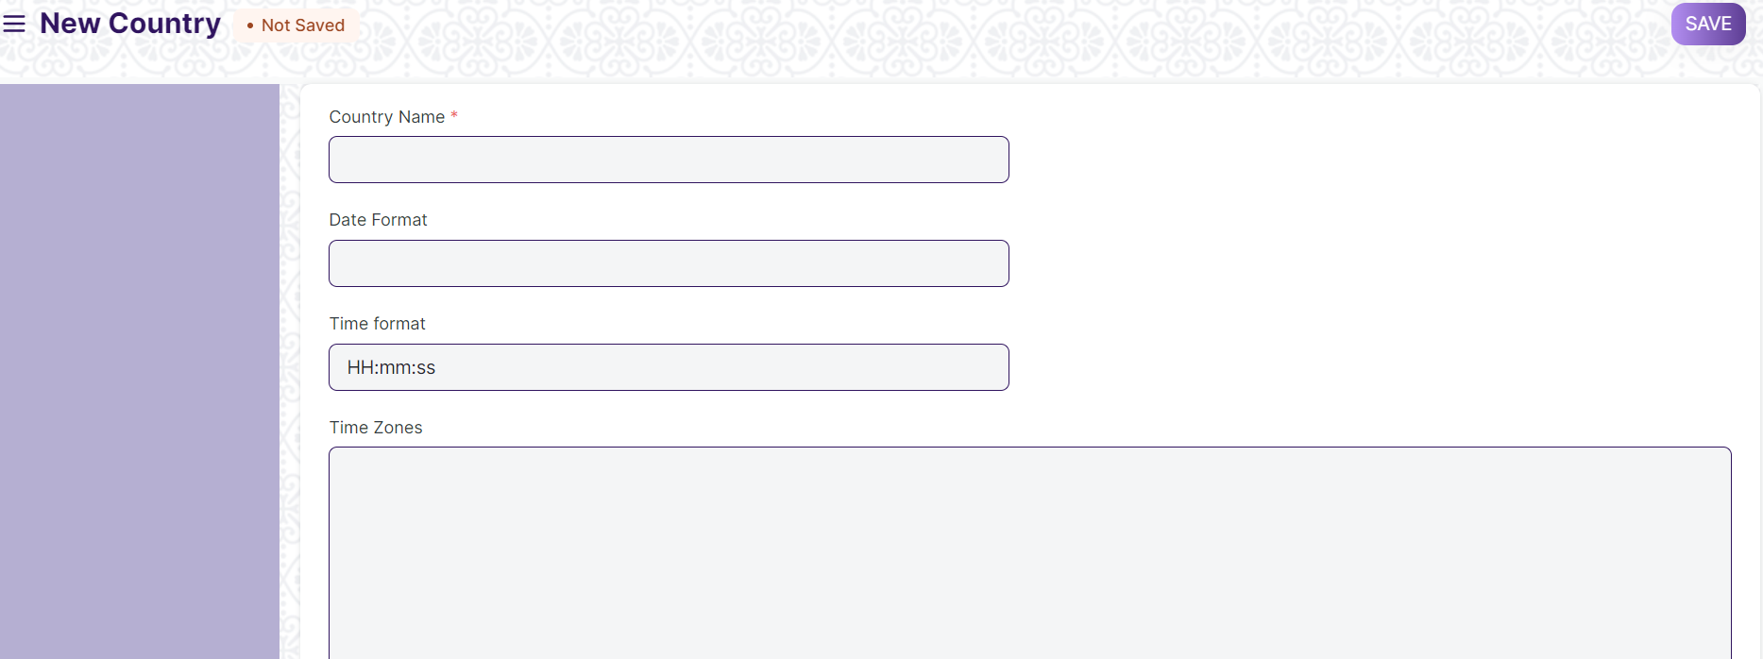

Field List

The following table describes the UI fields present in this screen:

ID | Label | Type | Mandatory | Validation / Action
1 | Country Name | Text | Yes
2 | Date Format | Text
3 | Time Format | Text
4 | Time Zones | Long Text
5 | Code | Text
6 | Country Phone Code | Text

Users: Roles & Permission

The following table describes the users and their roles and permissions for the screens :

ID | Role | Select | Read | Write | Create | Delete | Submit | Cancel | Amend
1 | Admin | Yes | Yes | Yes | Yes | Yes | NA | NA | NA

1.27 State

General Description

The following table describes overall information about this screen:
Description | State is Master Screen, you can create different states such as Odisha, West Bengal, etc
Navigation
Pre-requisites | Country

Screenshot

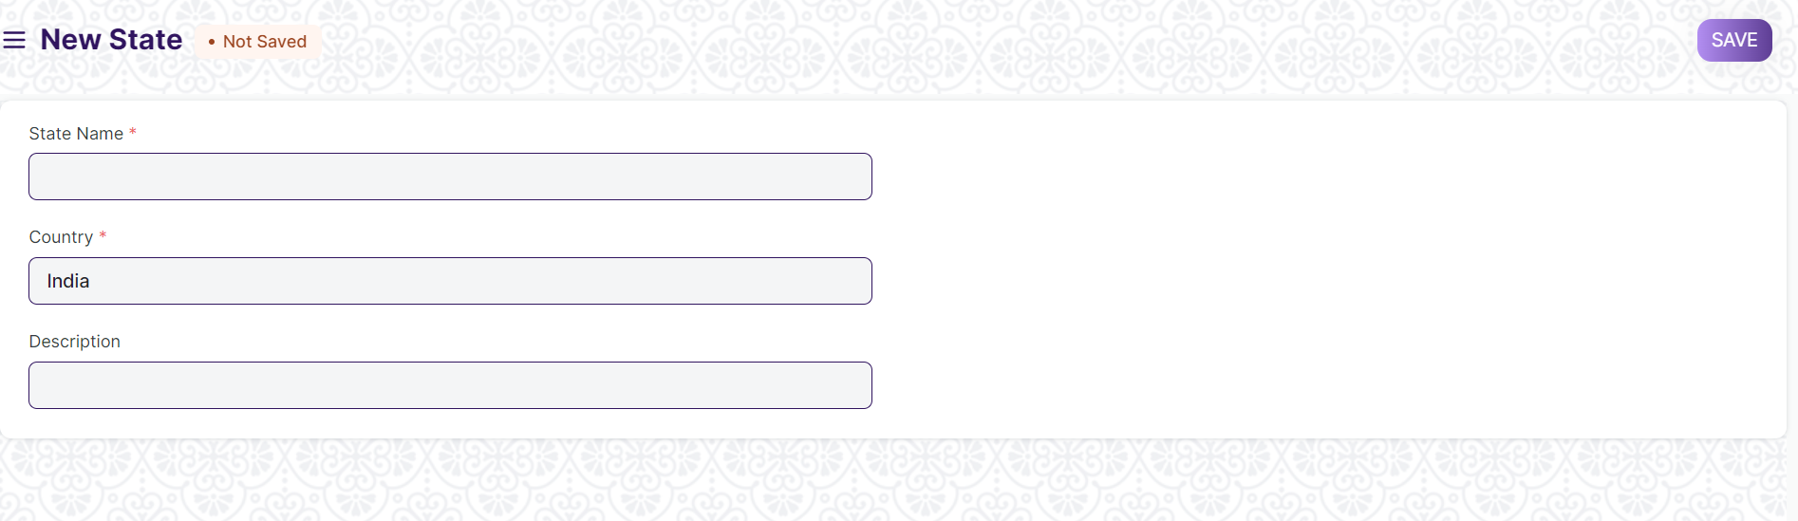

Field List

The following table describes the UI fields present in this screen :

ID | Label | Type | Mandatory | Validation / Action
1 | State Name | Text | Yes
2 | Country | Link Field |  | Links to Country Screen
3 | Description | Long Text

Users: Roles & Permission

The following table describes the users and their roles and permissions for the screens :

ID | Role | Select | Read | Write | Create | Delete | Submit | Cancel | Amend
1 | Admin | Yes | Yes | Yes | Yes | Yes | NA | NA | NA
2 | Student Applicant | Yes | Yes | No | No | No | No | No | No
3 | Student | Yes | Yes | No | No | No | No | No | No

1.28 Districts

General Description

The following table describe overall information about this screen:
Description | District is Master Screen, you can create different district name such as Khordha, Kandhamal, etc in the state Odisha
Navigation
Pre-requisites | State

Screenshot

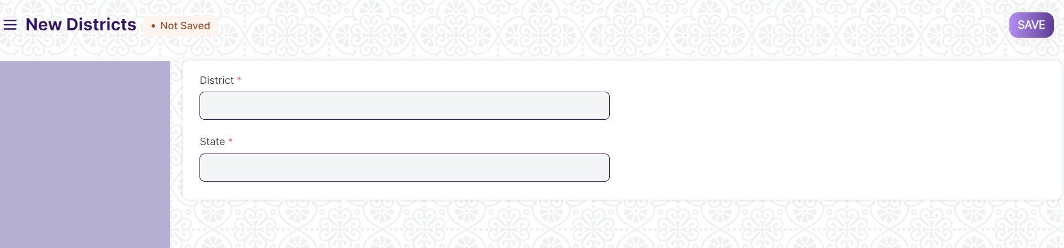

Field List

The following table describes the UI fields present in this screen :
ID | Label | Type | Mandatory | Validation / Action
1 | District | Text | Yes
2 | State | Links to State Screen

Users: Roles & Permission

The following table describes the users and their roles and permissions for the screens :

ID | Role | Select | Read | Write | Create | Delete | Submit | Cancel | Amend
1 | Admin | Yes | Yes | Yes | Yes | Yes | NA | NA | NA
2 | Student Applicant | Yes | Yes | No | No | No | No | No | No
3 | Student | Yes | Yes | No | No | No | No | No | No

1.29 Block

General Description

The following table describe overall information about this screen:
Description | Block is Master Screen, you can create different blocks name such as Baranga, Niali, etc in the Cuttack district of Odisha
Navigation
Pre-requisites | District

Screenshot

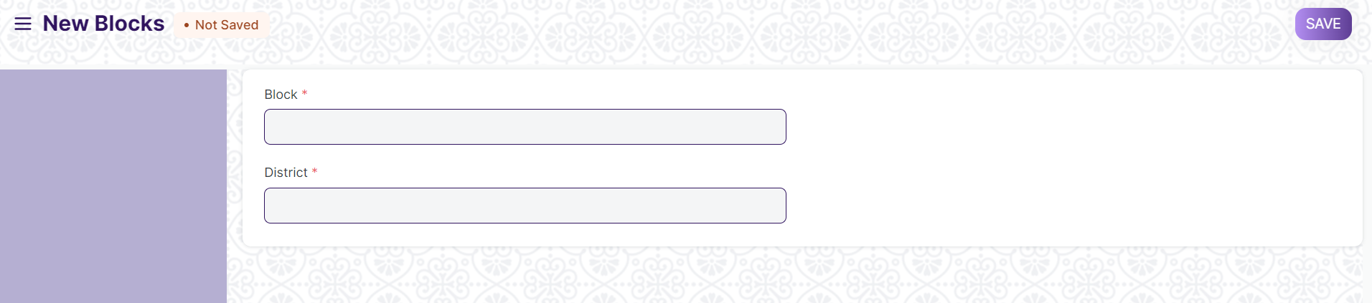

Field List

The following table describes the UI fields present in this screen :
ID | Label | Type | Mandatory | Validation / Action
1 | Block Name | Text | Yes
2 | District | Links to State Screen

Users: Roles & Permission

The following table describes the users and their roles and permissions for the screens :

ID | Role | Select | Read | Write | Create | Delete | Submit | Cancel | Amend
1 | Admin | Yes | Yes | Yes | Yes | Yes | NA | NA | NA
2 | Student Applicant | Yes | Yes | No | No | No | No | No | No
3 | Student | Yes | Yes | No | No | No | No | No | No

1.30 Documents

General Description

The following table describe overall information about this screen:
Description | Document is Master Screen, you can create different documents name such as Aadhar Card, Income Certificate, Caste Certificates, etc. so that in student application form, applicants can attached their respective documents accordingly.
Navigation
Pre-requisites

Screenshot

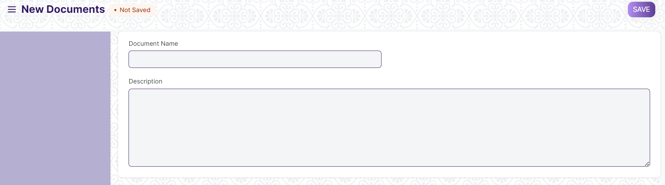

Field List

The following table describes the UI fields present in this screen :

ID | Label | Type | Mandatory | Validation / Action
1 | Document Name | Text | Yes
2 | District | Links to State Screen

Users: Roles & Permission

The following table describes the users and their roles and permissions for the screens :

ID | Role | Select | Read | Write | Create | Delete | Submit | Cancel | Amend
1 | Admin | Yes | Yes | Yes | Yes | Yes | NA | NA | NA
2 | Student Applicant | Yes | Yes | No | No | No | No | No | No
3 | Student | Yes | Yes | No | No | No | No | No | No

1.31 Eligibility Parameter

General Description

The following table describe overall information about this screen:
Description | Eligibility Parameter is Master Screen, you can create different eligibility parameters name such as 10th, 12th, ITI, Poly technique, etc. so that in student application form, applicants can add their details regarding their respective Eligibility Parameters accordingly.
Navigation
Pre-requisites

Screenshot

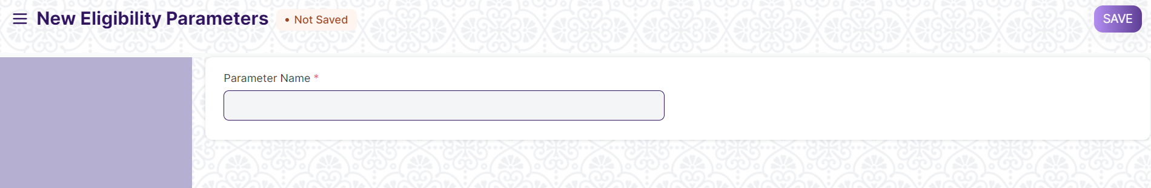

Field List

The following table describes the UI fields present in this screen:

ID | Label | Type | Mandatory | Validation / Action
1 | Parameter Name | Text | Yes

Users: Roles & Permission

The following table describes the users and their roles and permissions for the screens:

ID | Role | Select | Read | Write | Create | Delete | Submit | Cancel | Amend
1 | Admin | Yes | Yes | Yes | Yes | Yes | NA | NA | NA
2 | Student | Yes | Yes | No | No | No | No | No | No
3 | Student Applicant | Yes | Yes | No | No | No | No | No | No

1.32 Student Batch Name

General Description

The following table describes overall information about this screen:
Description | Student Batch Name is a Master Screen, where we can grouped them on the basis of Academic Batch
Navigation
Pre-requisites

Screenshot

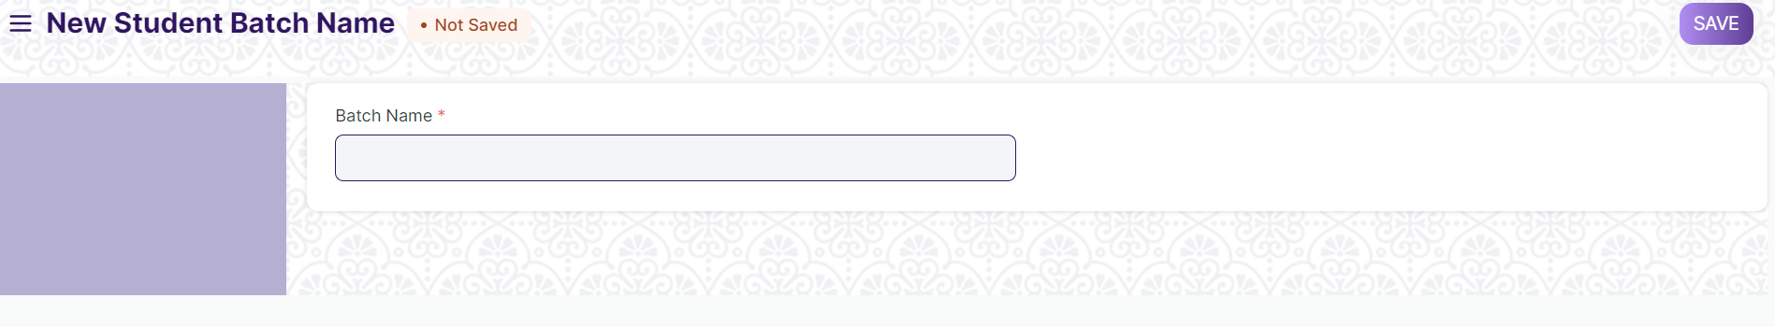

Field List

The following table describes the UI fields present in this screen :

ID | Label | Type | Mandatory | Validation / Action
1 | Batch Name | Text | Yes

Users: Roles & Permission

The following table describes the users and their roles and permissions for the screens :

ID | Role | Select | Read | Write | Create | Delete | Submit | Cancel | Amend
1 | Admin | Yes | Yes | Yes | Yes | Yes | NA | NA | NA
2 | Student | Yes | Yes | No | No | No | No | No | No
3 | Instructor | Yes | Yes | No | No | No | No | No | No

1.33 Religion

General Description

The following table describes overall information about this screen:
Description | Religion is a Master Screen, where we can create different religion names such Muslim, Hinduism, Christianity, etc.
Navigation
Pre-requisites

Screenshot

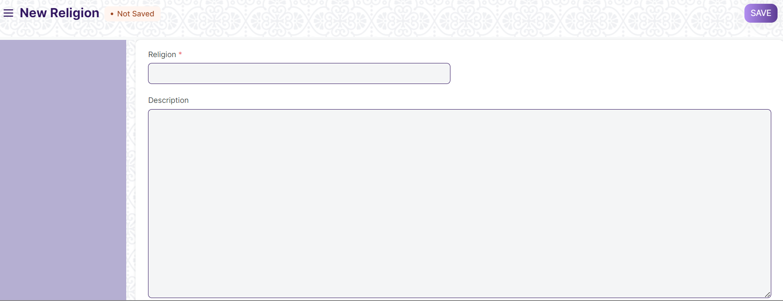

Field List

The following table describes the UI fields present in this screen:

ID | Label | Type | Mandatory | Validation / Action
1 | Religion | Text | Yes
2 | Description | Long Text

Users: Roles & Permission

The following table describes the users and their roles and permissions for the screens :

ID | Role | Select | Read | Write | Create | Delete | Submit | Cancel | Amend
1 | Admin | Yes | Yes | Yes | Yes | Yes | NA | NA | NA
2 | Student | Yes | Yes | No | No | No | No | No | No
3 | Student Applicant | Yes | Yes | No | No | No | No | No | No

1.34 Fee Type

General Description

The following table describes overall information about this screen:
Description | Fee Type is a Master Screen where we can create different fee types such as Semester Fees, Hostel Fees, Mess Fees, etc.
Navigation
Pre-requisites

Screenshot

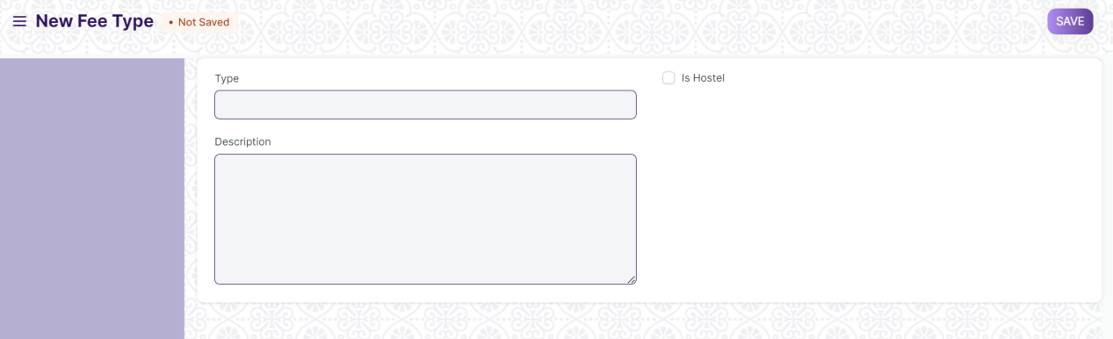

Field List

The following table describes the UI fields present in this screen :

ID | Label | Type | Mandatory | Validation / Action
1 | Type | Text | Yes
2 | Description | Long Text

Users: Roles & Permission

The following table describes the users and their roles and permissions for the screens :

ID | Role | Select | Read | Write | Create | Delete | Submit | Cancel | Amend
1 | Admin | Yes | Yes | Yes | Yes | Yes | NA | NA | NA
2 | Student | No | Yes | No | No | No | No | No | No

1.35 Entrance Exam Evaluation

General Description

The following table describes overall information about this screen:
Description | Entrance Exam Evaluation screen contains the entrance result of student applicants
Navigation
Pre-requisites | - Student Applicants  - Entrance Exam Evaluation  - Student Applicant Admit Card

Screenshot

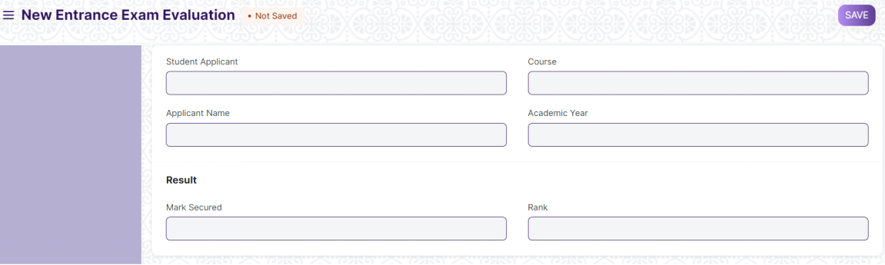

Field List

The following table describes the UI fields present in this screen :

ID | Label | Type | Mandatory | Validation / Action
1 | Student Applicant | Link | Yes | Links to Student Applicant Screen
2 | Applicant Name | Text |  | Applicant Name auto fetched from Student Applicant Link Screen
3 | Course | Link |  | Links to Program Screen and data fetched from the Student Applicant Screen
4 | Academic Year | Link |  | Links to Academic Year Screen
5 | Mark Secured | Number | Yes
6 | Rank | Number | Yes

Users: Roles & Permission

The following table describes the users and their roles and permissions for the screens :

ID | Role | Select | Read | Write | Create | Delete | Submit | Cancel | Amend
1 | Admin | Yes | Yes | Yes | Yes | Yes | NA | NA | NA
2 | Student Applicant | Yes | Yes | No | No | No | No | No | No

